Spring Framework

What Is Spring?
The core of the Spring Framework is based on the principle of Inversion of Control (IoC). Applications that follow the IoC principle use configuration that describes the dependencies between its components. It is then up to the IoC framework to satisfy the configured dependencies. The “inversion” means that the application does not control its structure; it is up to the IoC framework to do that.

Spring’s DI implementation puts focus on loose coupling: the components of your application should assume as little as possible about other components. The easiest way to achieve loose coupling in Java is to code to interfaces. Imagine your application’s code as a system of components: in a web application, you will have components that handle the HTTP requests and then use the components that contain the business logic of the application. The business logic components, in turn, use the data access objects (DAOs) to persist the data to a database. The important concept is that each component does not know what concrete implementation it is using; it only sees an interface. Because each component of the application is aware only of the interfaces of the other components, we can switch the implementation of the components (or entire groups or layers of components) without affecting the components that use the changed components. Spring’s DI core uses the information from your application’s configuration files to satisfy the dependencies between its components. The easiest way to allow Spring to set the dependencies is to follow the JavaBean naming conventions in your components, but it is not a strict requirement.

In the context of DI, Spring acts more like a container than a framework—providing instances of your application classes with all the dependencies they need—but it does so in amuch less intrusive way than, say, the EJB container that allows you to create persistent entity beans. Most importantly, Spring will manage the dependencies between the components of your application automatically. All you have to do is create a configuration file that describes the dependencies; Spring will take care of the rest. Using Spring for DI requires nothing more than following the JavaBeans naming conventions within your classes there are no special classes from which to inherit or proprietary naming schemes to follow. If anything, the only change you make in an application that uses DI is to expose more properties on your JavaBeans, thus allowing more dependencies to be injected at runtime.

Reduce glue code: One of the biggest plus points of DI is its ability to reduce dramatically the amount of code you have to write to glue the different components of your application together. Often, this code is trivial—where creating a dependency involves simply creating a new instance of a class. However, the glue code can get quite complex when you need to look up dependencies in a JNDI repository or when the dependencies cannot be invoked directly, as is the case with remote resources. In these cases, DI can really simplify the glue code by providing automatic JNDI lookup and automatic proxying of remote resources.

Externalize dependencies: You can externalize the configuration of dependencies, which allows you to reconfigure easily without needing to recompile your application. This gives you two interesting benefits. First, DI in Spring gives you the ideal mechanism for externalizing all the configuration options of your application for free. Second, this externalization of dependencies makes it much simpler to swap one implementation of a dependency for another. Consider the case where you have a DAO component that performs data operations against a PostgreSQL database and you want to upgrade to Oracle. Using DI, you can simply reconfigure the appropriate dependency on your business objects to use the Oracle implementation rather than the PostgreSQL one.

Manage dependencies in a single place: In the traditional approach to dependency management, you create instances of your dependencies where they are needed—within the dependent class. Even worse, in typical large applications, you usually use a factory or locator to find the dependent components. That means that your code depends on the factory or locator as well as the actual dependency. In all but the most trivial of applications, you will have dependencies spread across the classes in your application, and changing them can prove problematic. When you use DI, all the information about dependencies is the responsibility of a single component (the Spring IoC container), making the management of dependencies much simpler and less error prone.

Improve testability: When you design your classes for DI, you make it possible to replace dependencies easily. This comes in especially handy when you are testing your application. Consider a business object that performs some complex processing; for part of this, it uses a DAO object to access data stored in a relational database. You are not interested in testing the DAO; you simply want to test the business object with various sets of data. In a traditional approach, where the service object is responsible for obtaining an instance of the DAO itself, you have a hard time testing this, because you are unable to replace the DAO implementation easily with a dummy implementation that returns your test data. Instead, you need to make sure that your test database contains the correct data and uses the full DAO implementation for your tests. Using DI, you can create a mock implementation of the DAO that returns the test data, and then you can pass this to your service object for testing. This mechanism can be extended for testing any tier of your application and is especially useful for testing web components, where you can create fake implementations of HttpServletRequest and HttpServletResponse.

Foster good application design: Designing for DI means, in general, designing against interfaces. A typical injection-oriented application is designed so that all major components are defined as interfaces, and then concrete implementations of these interfaces are created and wired together using the DI container.

Aspect-Oriented Programming with Spring
AOP lets you implement crosscutting logic—that is, logic that applies to many parts of your application—in a single place, and then have that logic automatically applied right across the application. AOP is enjoying an immense amount of time in the limelight at the moment; however, behind all the hype is a truly useful technology that has a place in any Java developer’s toolbox.

There are two main kinds of AOP implementation. Static AOP, such as AspectJ (www.aspectj.org), provides a compile-time solution for building AOP-based logic and adding it to an application. Dynamic AOP, such as that in Spring, allows crosscutting logic to be applied arbitrarily to any other code at runtime. Finally, in Spring 2.5, you can use load-time dynamic weaving, which applies the crosscutting logic when the class loader loads the class. Both kinds of AOP have their places, and indeed, Spring provides features to integrate with AspectJ.

Accessing Data in Spring
Data access and persistence seem to be the most often discussed topics in the Java world. It seems that you cannot visit a community site such as www.theserverside.com without being bombarded with articles and blog entries describing the latest, greatest data access tool.
Spring provides excellent integration with a choice selection of these data access tools. Moreover, Spring makes the use of JDBC, a viable option for many projects thanks to its simplified wrapper APIs around the standard JDBC API. As of Spring version 1.1, you have support for JDBC, Hibernate, iBATIS, and Java Data Objects (JDO).
The JDBC support in Spring makes building an application on top of JDBC realistic, even for complex applications. The support for Hibernate, iBATIS, and JDO makes their already simple APIs even simpler, thus easing the burden on developers. When using the Spring APIs to access data via any tool, you can take advantage of Spring’s excellent transaction support.

One of Spring’s nicest features is the ability to mix and match data access technologies easily within an application. For instance, you may be running an application with Oracle, using Hibernate for much of your data access logic. However, if you want to take advantage of Oracle-specific features, it is simple to implement that particular part of your data access tier using Spring’s JDBC APIs.

Simplifying and Integrating with Java EE
Spring provides a selection of classes for building and accessing EJB resources. These classes cut out a lot of the grunt work from both tasks and provide a more DI-oriented API for EJBs. For any resources stored in a JNDI-accessible location, Spring allows you to do away with the complex lookup code and have JNDI-managed resources injected as dependencies into other objects at runtime. As a side effect of this, your application code becomes decoupled from JNDI, giving you more scope for code reuse in the future.
As of version 1.0.2, Spring does not support JMS access. However, the CVS repository already contains a large array of classes that are to be introduced in 1.1. Using these classes simplifies all interaction with Java Message Service (JMS) destinations and should reduce a lot of the boilerplate code you need to write in order to use JMS from your Spring applications.

Job Scheduling Support
Many advanced applications require some kind of scheduling capability. Whether for sending updates to customers or doing housekeeping tasks, the ability to schedule code to run at a predefined time is an invaluable tool for developers.
Spring supports two scheduling mechanisms: one uses the Timer class, which has been available since Java 1.3; and the other uses the Quartz scheduling engine. Scheduling based on the Timer class is quite primitive and is limited to fixed periods defined in milliseconds. With Quartz, on the other hand, you can build complex schedules using the Unix cron format to define when tasks should be run.

Mail Support
Sending e-mail is a typical requirement for many different kinds of applications and is given first-class treatment within the Spring Framework. Spring provides a simplified API for sending e-mail messages that fits nicely with its DI capabilities. It supports pluggable implementations of the mail API and comes complete with two implementations: one uses JavaMail, and the other uses Jason Hunter’s
MailMessage class from the com.oreilly.servlet package available from http://servlets.com/cos. Spring lets you create a prototype message in the DI container and use this as the base for all messages sent from your application. This allows for easy customization of mail parameters such as the subject and sender address. However, there is no support for customizing the message body outside of the code.

Dynamic Languages
Dynamic languages in Spring allow you to implement components of your application in languages other than Java (Spring 2.5 supports BeanShell, JRuby, and Groovy). This allows you to externalize part of your application’s code so that it can be easily updated by administrators and power users. You could do this even without Spring, but the support built into Spring means that the rest of your application will not be aware that a component is implemented in another language; it will appear to be an ordinary Spring bean.
Many large applications have to deal with complex business processes. This would not be too difficult to handle in Java, but in most cases, these processes change over time, and users want to be able to make the changes themselves. This is where a domain-specific language implementation comes in.

Remoting Support
Accessing or exposing remote components in Java has never been simple. Using Spring, you can take advantage of extensive support for a wide range of remoting techniques that help you expose and access remote services quickly. Spring supports a variety of remote access mechanisms, including Java RMI, JAX-RPC, Caucho Hessian, and Caucho Burlap. In addition to these remoting protocols, Spring 1.1 introduced its own HTTP-based protocol that is based on standard Java serialization. By applying Spring’s dynamic proxying capabilities, you can have a proxy to a remote resource injected as a dependency into one of your components, thus removing the need to couple your application to a specific remoting implementation and also reducing the amount of code you need to write for your application.
As well as making it easy to access remote components, Spring provides excellent support for exposing a Spring-managed resource as a remote service. This lets you export your service using any of the remoting mechanisms mentioned earlier, without needing any implementation-specific code in your application.
Integrating applications written in different programming languages, and possibly running on different platforms, is one of the most compelling reasons for using remote services.

Managing Transactions
Spring provides an excellent abstraction layer for transaction management, allowing for programmatic and declarative transaction control. By using the Spring abstraction layer for transactions, you can easily change the underlying transaction protocol and resource managers. You can start with simple, local, resource-specific transactions and move to global, multiresource transactions without having to change your code.

The Spring MVC Framework
Although Spring can be used in almost any application, from a service-only application, through web and rich-client ones, it provides a rich array of classes for creating web-based applications. Using Spring, you have maximum flexibility when you are choosing how to implement your web front end.
For a web application of any complexity, it makes sense to use a framework with a paradigm that clearly separates the processing logic from the views. To achieve this, you can use the Spring Struts support or use Spring’s own excellent MVC framework. To implement complex page flows, you can use Spring Web Flow. You can use a large array of different view technologies, from JavaServer Pages (JSP) and Apache’s Jakarta Velocity to Apache POI (to generate Microsoft Excel output) and iText (to create output in Adobe PDF format). The Spring MVC framework is quite comprehensive and provides support classes that address the majority of your requirements. For the rest, you can easily extend the MVC framework to add in your own functionality.
The view support in Spring MVC is extensive and steadily improving. As well as standard support for JSP, which is greatly bolstered by the Spring tag libraries, you can take advantage of fully integrated support for Jakarta Velocity, FreeMarker, Jakarta Tiles (separate from Struts), and XSLT. Moreover, you will find a set of base view classes that make it simple to add Excel and PDF output to your applications.

Spring Web Flow
Web Flow represents a new way of developing web applications, especially ones that rely on fairly complex transitions between the pages. Web Flow greatly simplifies the implementation of such systems. Because it is a Spring project, it integrates closely with the Spring MVC framework. Just like Spring MVC, Web Flow can use any type of view technology.

AJAX
AJAX is not only a buzzword of Web 2.0 but also an important technique for creating rich web applications. Put simply, it allows web applications to interact with servers without causing unnecessary page reloads. You may argue that it has little to do with the Spring Framework, but if you need to build highly interactive Web 2.0 applications, you cannot escape it.
Spring does not provide any framework-level infrastructure to deal with the implementation of AJAX web applications.

Internationalization
Internationalization is an important aspect of any large application; Spring has extensive support for creating multilanguage applications, and we will show you how to deal with the complexities of this task. The issues facing the developers of multilanguage applications are twofold: first, they must write code without any textual information hard-coded; second, they must design the application in a way that will allow for easy translation in the future.

Simplified Exception Handling
One area where Spring really helps to reduce the amount of repetitive, boilerplate code you need to write is exception handling. The Spring philosophy is that checked exceptions are overused in Java and that a framework should not force you to catch any exception from which you are unlikely to be able to recover—a point of view that we agree with wholeheartedly.
In reality, many frameworks reduce the impact of having to write code to handle checked exceptions. However, many of these frameworks take the approach of sticking with checked exceptions but artificially reducing the granularity of the exception class hierarchy. One thing you will notice with Spring is that, because of the convenience afforded to the developer by using unchecked exceptions, the exception hierarchy is remarkably granular.

Obtaining the Spring Framework
The Spring Framework is now part of the Spring portfolio, which includes projects that are closely associated with the framework. The portfolio includes Spring Web Flow, Spring Security (formerly Acegi Security for Spring), Spring Web Services, Spring Batch, and Spring Integration. There are many other exciting projects, among the most notable are Spring Dynamic Modules for OSGi, Spring Rich Client, Spring IDE, and many others; all are available at ww.springframework.org/projects.

Checking Out Spring from CVS
Spring is under constant development with many new features being added almost daily. If you want to get a grip on new features before they make their way into a release, then obtaining the latest source code from CVS is the best way of going about it.
To check out the latest version of the Spring code, install CVS, which you can download from www.cvshome.org, and run the following command:
cvs -d:pserver:anonymous@springframework.cvs.sourceforge.net:/cvsroot/springframework login

When prompted for your password, simply press Enter to send a blank password. Next, enter the following command to check out the HEAD of the CVS repository, which contains the latest changes that have been committed:
cvs -z3 -d:pserver:anonymous@springframework.cvs.sourceforge.net:
/cvsroot/springframework co -P spring

Spring Packaging
When you unzip the full Spring distribution or compile the source distribution, the dist subdirectory contains the full Spring distribution. However, there are many different JARs and, even more confusingly, spring.jar. The reason for this split is that some applications may not require the entire Spring Framework. The decision whether to use various smaller JARs or the entire spring.jar depends on the type of application you are writing and on its environment. Most applications work absolutely fine with the entire spring.jar on the classpath. However, if you deploy your application in an application server that already contains other versions of the Spring Framework libraries, you may come across versioning conflicts. Another situation where you may not want to include the entire spring.jar in your application is if you wish to use only parts of the Spring’s code.

spring-aop.jar
This JAR contains all the classes you need to use Spring’s AOP features within your application. You also need to include this JAR in your application if you plan to use other features in Spring that use AOP, such as declarative transaction management.

spring-beans.jar
This archive contains all of Spring’s dependency injection. It contains the bean factories and supporting classes. In most cases, you will need to add spring-context.jar, which contains code needed to build the application context.

spring-context.jar
This JAR contains code needed to build the Spring application context; it packages the main ApplicationConext interface and its implementations together with code for instrumentation, JNDI, scheduling, themes, and validation.

spring-context-support.jar
This package contains utility Spring code—this means caching, instrumentation, e-mail and scheduling support, and the very interesting scripting languages support.

spring-core.jar
This contains the core files of the Spring Framework: it deals with annotations, enumerations, task execution, resource loading, and other utilities and exceptions you may find useful even outside the context of the Spring Framework.

spring-jdbc.jar
This package contains code for the JDBC support classes, namely the JdbcTemplate and JdbcDaoSupport classes;

spring-jms.jar
This JAR contains code for JMS;

spring-orm.jar
This archive contains the files needed for object-relational mapping (ORM) tools. Including this package on your classpath will give you
Spring support for Hibernate 3, iBATIS, JDO, JPA, and TopLink.

spring-test.jar
This package contains support code to write unit and integration tests using the Spring Framework. It supports the JUnit 3, JUnit 4, and TestNG testing frameworks. In addition, you can use classes from the org.springframework.mock package, which represent mock implementations of JNDI and web classes.

spring-tx.jar
This one contains support for core data access exceptions and transaction technologies. These two areas are closely bound together, because the transactions generally work with some data access code.

spring-web.jar
This JAR contains code for the Spring web application support (utilities, binders, multipart resolvers).

spring-webmvc-portlet.jar
This JAR contains code needed to build portlet-based (rather than servlet-based) web applications. If you have an application server that supports the Portlet API (JSR 168), you can use this package.

spring-webmvc-struts.jar
This package contains code needed to use Spring with the Jakarta Struts Framework.

spring-webmvc.jar This package contains the Spring MVC code;

Spring Dependencies
If we leave the dist directory and go to the lib directory, you will notice that it contains a large number of libraries. These dependencies are necessary to build and test the entire Spring Framework distribution, but not all of the dependencies will be needed in your applications.

ant - ant.jar, ant-junit.jar,
Spring uses Apache Ant as its build tool, ant-launcher.jar as well as for many tasks such as generating documentation and running tests. Ant is not used at all at runtime, so you do not need to include this JAR file in your distribution

aopalliance - aopalliance.jar
The AOP Alliance (http://aopalliance.sourceforge.net/) is a combined, open source collaboration between many projects to provide a standard set of interfaces for AOP in Java. Spring’s AOP implementation is based on the standard AOP Alliance APIs. You only need this JAR file if you plan to use Spring’s AOP or AOP-based features.

axis - axis.jar, saaj.jar, wsdl4j.jar
Spring uses the Apache Axis project to support the JAX-RPC capabilities in Spring remoting. You only need these files if you are using JAX-RPC remoting.

caucho - burlap-2.1.7.jar, hessian-3.0.13.jar
Spring remoting provides support for a wide variety of different protocols, including Caucho’s Burlap and Hessian. You only need
the JARs in this group if you are using the corresponding protocols in your application.

cglib - cglib-full-2.0.2.jar
CGLIB is used to generate dynamic proxy classes for use in both the core DI and AOP implementations. You almost always need to include CGLIB with your application, because it is used to implement a wide range of Spring’s functionality.

cos - cos.jar
COS stands for com.oreilly.servlet, which is a collection of useful classes for working with servlets and web-based applications. Spring uses COS in two areas: for handling file uploads and sending e-mail. In both cases, COS is just an implementation choice, so you only need to include cos.jar if you choose to use COS over one of the other implementations.

dom4j - dom4j.jar
You must have dom4j when you are using Hibernate, so you need to include this JAR file if you plan to use Hibernate for ORM in your application.

easymock - easymock.jar, easymockclassextension.jar
EasyMock is used in the Spring test suite, so you only need to use this JAR for building and running the test suite; you do not need to distribute this with your application.

Freemarker - freemaker.jar
Spring provides wrapper classes around the FreeMarker templating engine and also provides support for using FreeMarker templates as views for your web applications. This is required whenever you are using FreeMarker.

hibernate - ehcache.jar, hibernate3.jar, odmg.jar
These JAR files are required when you are using Spring’s Hibernate integration and support classes. If you are using a different ORM tool, such as iBATIS, you can leave these JARs out of your application. When you are using Hibernate, you must also include the CGLIB JAR file in your application.

hsqldb - hsqldb.jar
The hsqldb.jar file is used by the Spring sample applications.

ibatis - ibatis-common.jar, ibatis-sqlmap.jar, ibatis-sqlmap-2.jar
These files are required when you are using Spring’s iBATIS integration classes, but you can leave them out of your application if you are using JDBC or another ORM tool such as Hibernate or JDO.

itext - itext-1.3.1.jar
Spring uses iText to provide PDF support in the web tier. Only include this JAR if your web applications need to generate PDF output.

j2ee - activation.jar, connector-api.jar, ejb.jar, jaxrpc.jar, jdbc2_0-stdext.jar, jms.jar, jstl.jar, jta.jar, mail.jar, servlet.jar, xml-apis.jar
As you can see, there is a large array of different Java EE-related JAR files. You need the activation.jar and mail.jar files if you want to use the JavaMail implemen tation of Spring’s mail support. You need connector-api.jar to use the JCA connector for Hibernate, ejb.jar to use Spring’s EJB support, and jms.jar to use Spring’s JMS support. For web applications, you need servlet.jar, and you need jstl.jar if you want to use Spring’s JSTL support. The jaxrpc.jar file is required for JAX-RPC support in Spring remoting, and jta.jar is used for JTA transaction support. The remaining two jars, jdbc2_0-stdext.jar and xml-apis.jar, are needed for JDBC and XML configuration support, respectively—but only when you are using a version 1.3 JVM.

Jakarta - jakarta-commons commons-attributes-api.jar, commons-attributes- compiler.jar, commons-beanutils.jar, commons-collections.jar, commons-dbcp.jar, commons-digester.jar, commons-discovery.jar, commons-fileupload.jar, commons-lang.jar, commons-logging.jar, commons-pool.jar, commons-validator.jar
Many of the components from the Jakarta Commons project are used by Spring. You need the commons-attribute-api.jar if you want to use source-level metadata in your application, plus you need the compiler JAR file to compile the attributes into your application. The beanutils, collections, digester, discovery, and validator JAR files are used by Struts, and Hibernate uses collections as well. dbcp is used by Spring’s JDBC support when you are using DBCP connection pools, and pooling is required by some of the sample applications. fileupload is required if you want to use the corresponding Spring wrapper to handle file uploads in your web applications. Finally, logging is used throughout Spring, so you need to include it in every Spring-based application.

jakarta-taglibs - standard.jar
This is the Jakarta JSTL implementation, and it is used by some of the Spring sample applications.

Jboss - jboss-common-jdbc-wrapper.jar
This is required when you are using Spring’s JDBC classes in an application running on the JBoss application server.

Jdo - jdo.jar
This is required for Spring’s JDO support.

jdom - jdom.jar
JDOM is required when you are using iBATIS 1.3 with Spring. The version of iBATIS covered in this chapter is 2.0.

Jotm - jotm.jar, xapool.jar
The jotm.jar file is required if you plan to use JOTM in conjunction with Spring’s transaction abstraction layer. You only need xapool.jar if you plan to use XAPool for connection pooling in your application.

junit - junit.jar
JUnit is not required at all at runtime; it is only used for building and running the test suite.

log4j - log4j-1.2.14.jar
This is required when you want to use Spring to configure log4j logging.

Poi - poi-2.5.1.jar
This adds support for Microsoft Excel output to Spring’s MVC framework.

quartz - quartz.jar
This is used for Spring Quartz-based scheduling support.

regexp - jakarta-oro-2.0.7.jar
This is required when you are using regular expressions to specify point cuts in AOP.

Dependency Injection
Spring Framework works on one single mantra: Dependency Injection. This is sometimes interchangeable with the Inversion of Control (IoC) principle. When a standalone program starts, it starts the main program, creates the dependencies, and then proceeds to execute the appropriate methods. However, this is exactly the reverse if IoC is applied. That is, all the dependencies and relationships are created by the IoC container and then they are injected into the main program as properties. The program is then ready for action. This is essentially the reverse of usual program creation and hence is called Inversion of Control principle. The DI and IoC are often used interchangeably.

The IoC container
BeanFactory or ApplicationContext?
Users are sometimes unsure whether a BeanFactory or an ApplicationContext is best suited for use in a particular situation. A BeanFactory pretty much just instantiates and configures beans. An ApplicationContext also does that, and it provides the supporting infrastructure to enable lots of
enterprise-specific features such as transactions and AOP.

The org.springframework.beans and org.springframework.context packages provide the basis for the Spring Framework's IoC container. The BeanFactory interface provides an advanced configuration mechanism capable of managing objects of any nature. The ApplicationContext interface builds on top of the BeanFactory (it is a sub-interface) and adds other functionality such as easier integration with Spring's AOP features, message resource handling (for use in internationalization), event propagation, and application-layer specific contexts such as the WebApplicationContext for use in web applications.

In short, the BeanFactory provides the configuration framework and basic functionality, while the ApplicationContext adds more enterprise-centric functionality to it. The ApplicationContext is a complete superset of the BeanFactory, and any description of BeanFactory capabilities and behavior is to be considered to apply to the ApplicationContext as well.

The container
The org.springframework.beans.factory.BeanFactory is the actual representation of the Spring IoC container that is responsible for containing and otherwise managing the aforementioned beans. The BeanFactory interface is the central IoC container interface in Spring. Its responsibilities include instantiating or sourcing application objects, configuring such objects, and assembling the dependencies
between these objects.

Configuration metadata
As can be seen in the above image, the Spring IoC container consumes some form of configuration metadata; this configuration metadata is nothing more than how you (as an application developer) inform the Spring container as to how to “instantiate, configure, and assemble [the objects in your application]”. This configuration metadata is typically supplied in a simple and intuitive XML format. When using XML-based configuration metadata, you write bean definitions for those beans that you want the Spring IoC container to manage, and then let the container do its stuff.

<?xml version="1.0" encoding="UTF-8"?>
<beans xmlns="http://www.springframework.org/schema/beans"
xmlns:xsi="http://www.w3.org/2001/XMLSchema-instance"
xsi:schemaLocation="http://www.springframework.org/schema/beans
http://www.springframework.org/schema/beans/spring-beans-2.5.xsd">
<bean id="..." class="...">
<!-- collaborators and configuration for this bean go here -->
</bean>
<bean id="..." class="...">
<!-- collaborators and configuration for this bean go here -->
</bean>
<!-- more bean definitions go here -->
</beans>

Instantiating a Spring IoC container is straightforward.
ApplicationContext context = new ClassPathXmlApplicationContext(
new String[] {"services.xml", "daos.xml"});
// an ApplicationContext is also a BeanFactory (via inheritance)
BeanFactory factory = context;

It can often be useful to split up container definitions into multiple XML files. One way to then load an application context which is configured from all these XML fragments is to use the application context constructor which takes multiple Resource locations. With a bean factory, a bean definition reader can be used multiple times to read definitions from each file in turn.
Generally, the Spring team prefers the above approach, since it keeps container configuration files unaware of the fact that they are being combined with others. An alternate approach is to use one or more occurrences of the <import/> element to load bean definitions from another file (or files). Let's look at a sample:

<beans>
<import resource="services.xml"/>
<import resource="resources/messageSource.xml"/>
<import resource="/resources/themeSource.xml"/>
<bean id="bean1" class="..."/>
<bean id="bean2" class="..."/>
</beans>

Instantiation using a constructor
<bean id="exampleBean" class="examples.ExampleBean"/>
<bean name="anotherExample" class="examples.ExampleBeanTwo"/>

Instantiation using a static factory method
<bean id="exampleBean" class="examples.ExampleBean2" factory-method="createInstance"/>

Instantiation using an instance factory method
<!-- the factory bean, which contains a method called createInstance() -->
<bean id="serviceLocator" class="com.foo.DefaultServiceLocator">
<!-- inject any dependencies required by this locator bean -->
</bean>
<!-- the bean to be created via the factory bean -->
<bean id="exampleBean" factory-bean="serviceLocator" factory-method="createInstance"/>

Dependencies
Your typical enterprise application is not made up of a single object (or bean in the Spring parlance). Even the simplest of applications will no doubt have at least a handful of objects that work together to present what the end-user sees as a coherent application. This next section explains how you go from defining a number of bean definitions that stand-alone, each to themselves, to a fully realized application where objects work (or collaborate) together to achieve some goal (usually an application that does what the end-user wants).

Injecting dependencies
The basic principle behind Dependency Injection (DI) is that objects define their dependencies (that is to say the other objects they work with) only through constructor arguments, arguments to a factory method, or properties which are set on the object instance after it has been constructed or returned from a factory method.
Then, it is the job of the container to actually inject those dependencies when it creates the bean. This is
fundamentally the inverse, hence the name Inversion of Control (IoC), of the bean itself being in control of instantiating or locating its dependencies on its own using direct construction of classes, or something like the Service Locator pattern.

Constructor Injection
Constructor-based DI is effected by invoking a constructor with a number of arguments, each representing a dependency. Additionally, calling a static factory method with specific arguments to construct the bean, can be considered almost equivalent, and the rest of this text will consider arguments to a constructor and arguments to a static factory method similarly.

public class SimpleMovieLister {
// the SimpleMovieLister has a dependency on a MovieFinder
private MovieFinder movieFinder;
// a constructor so that the Spring container can 'inject' a MovieFinder
public SimpleMovieLister(MovieFinder movieFinder) {
this.movieFinder = movieFinder;
}
// business logic that actually 'uses' the injected MovieFinder is omitted...
}

package x.y;
public class Foo {
public Foo(Bar bar, Baz baz) {
// ...
}
}

<beans>
<bean name="foo" class="x.y.Foo">
<constructor-arg>
<bean class="x.y.Bar"/>
</constructor-arg>
<constructor-arg>
<bean class="x.y.Baz"/>
</constructor-arg>
</bean>
</beans>

package examples;
public class ExampleBean {
// No. of years to the calculate the Ultimate Answer
private int years;
// The Answer to Life, the Universe, and Everything
private String ultimateAnswer;
public ExampleBean(int years, String ultimateAnswer) {
this.years = years;
this.ultimateAnswer = ultimateAnswer;
}
}

Constructor Argument Type Matching
<bean id="exampleBean" class="examples.ExampleBean">
<constructor-arg type="int" value="7500000"/>
<constructor-arg type="java.lang.String" value="42"/>
</bean>

Constructor Argument Index
<bean id="exampleBean" class="examples.ExampleBean">
<constructor-arg index="0" value="7500000"/>
<constructor-arg index="1" value="42"/>
</bean>

Setter Injection
Setter-based DI is realized by calling setter methods on your beans after invoking a no-argument constructor or no-argument static factory method to instantiate your bean.
Find below an example of a class that can only be dependency injected using pure setter injection. Note that there is nothing special about this class... it is plain old Java.

public class SimpleMovieLister {
// the SimpleMovieLister has a dependency on the MovieFinder
private MovieFinder movieFinder;
// a setter method so that the Spring container can 'inject' a MovieFinder
public void setMovieFinder(MovieFinder movieFinder) {
this.movieFinder = movieFinder;
}
// business logic that actually 'uses' the injected MovieFinder is omitted...
}

Constructor- or Setter-based DI?
The Spring team generally advocates the usage of setter injection, since a large number of constructor arguments can get unwieldy, especially when some properties are optional. The presence of setter methods also makes objects of that class amenable to being re-configured (or re-injected) at some later time (for management via JMX MBeans is a particularly compelling use case).
Constructor-injection is favored by some purists though (and with good reason). Supplying all of an object's dependencies means that that object is never returned to client (calling) code in a less than totally initialized state. The flip side is that the object becomes less amenable to re-configuration (or re-injection).
There is no hard and fast rule here. Use whatever type of DI makes the most sense for a particular class; sometimes, when dealing with third party classes to which you do not have the source, the choice will already have been made for you - a legacy class may not expose any setter methods, and so constructor injection will be the only type of DI available to you.

References to other beans (collaborators)
<!-- in the parent context -->
<bean id="accountService" class="com.foo.SimpleAccountService">
<!-- insert dependencies as required as here -->
</bean>

<!-- in the child (descendant) context -->
<bean id="accountService" <-- notice that the name of this bean is the same as the name of the 'parent' bean
class="org.springframework.aop.framework.ProxyFactoryBean">
<property name="target">
<ref parent="accountService"/> <-- notice how we refer to the parent bean
</property>
<!-- insert other configuration and dependencies as required as here -->
</bean>

Inner beans
<bean id="outer" class="...">
<!-- instead of using a reference to a target bean, simply define the target bean inline -->
<property name="target">
<bean class="com.example.Person"> <!-- this is the inner bean -->
<property name="name" value="Fiona Apple"/>
<property name="age" value="25"/>
</bean>
</property>
</bean>

Collections
The <list/>, <set/>, <map/>, and <props/> elements allow properties and arguments of the Java Collection type List, Set, Map, and Properties, respectively, to be defined and set.
<bean id="moreComplexObject" class="example.ComplexObject">
<!-- results in a setAdminEmails(java.util.Properties) call -->
<property name="adminEmails">
<props>
<prop key="administrator">administrator@example.org</prop>
<prop key="support">support@example.org</prop>
<prop key="development">development@example.org</prop>
</props>
</property>
<!-- results in a setSomeList(java.util.List) call -->
<property name="someList">
<list>
<value>a list element followed by a reference</value>
<ref bean="myDataSource" />
</list>
</property>
<!-- results in a setSomeMap(java.util.Map) call -->
<property name="someMap">
<map>
<entry>
<key>
<value>an entry</value>
</key>
<value>just some string</value>
</entry>
<entry>
<key>
<value>a ref</value>
</key>
<ref bean="myDataSource" />
</entry>
</map>
</property>
<!-- results in a setSomeSet(java.util.Set) call -->
<property name="someSet">
<set>
<value>just some string</value>
<ref bean="myDataSource" />
</set>
</property>
</bean>

Autowiring collaborators
The Spring container is able to autowire relationships between collaborating beans. This means that it is possible to automatically let Spring resolve collaborators (other beans) for your bean by inspecting the contents of the BeanFactory. The autowiring functionality has five modes. Autowiring is specified per bean and can thus be enabled for some beans, while other beans will not be autowired. Using autowiring, it is possible to reduce or eliminate the need to specify properties or constructor arguments, thus saving a significant amount of typing. 2 When using XML-based configuration metadata, the autowire mode for a bean definition is specified by using the autowire attribute of the <bean/> element. The following values are allowed:

Mode | Explanation
no | No autowiring at all. Bean references must be defined via a ref element. This is the default, and changing this is discouraged for larger deployments, since explicitly specifying collaborators gives greater control and clarity. To some extent, it is a form of  documentation about the structure of a system.
byName | Autowiring by property name. This option will inspect the container and look for a bean named exactly the same as the property which needs to be autowired. For example, if you have a bean definition which is set to autowire by name, and it contains a master property (that is, it has a setMaster(..) method), Spring will look for a bean definition named master, and use it to set the property.
byType | Allows a property to be autowired if there is exactly one bean of the property type in the container. If there is more than one, a fatal exception is thrown, and this indicates that you may not use byType autowiring for that bean. If there are no matching beans, nothing happens; the property is not set. If this is not desirable, setting the dependency-check="objects" attribute value specifies that an error should be thrown in this case.
constructor | This is analogous to byType, but applies to constructor arguments. If there isn't exactly one bean of the constructor argument type in the container, a fatal error is raised.
autodetect | Chooses constructor or byType through introspection of the bean class. If a default  constructor is found, the byType mode will be applied.

Checking for dependencies
The Spring IoC container also has the ability to check for the existence of unresolved dependencies of a bean deployed into the container. These are JavaBeans properties of the bean, which do not have actual values set for them in the bean definition, or alternately provided automatically by the autowiring feature. This feature is sometimes useful when you want to ensure that all properties (or all properties of a certain type) are set on a bean. Of course, in many cases a bean class will have default values for many properties, or some properties do not apply to all usage scenarios, so this feature is of limited use. Dependency checking can also be enabled and disabled per bean, just as with the autowiring functionality. The default is to not check dependencies. Dependency checking can be handled in several different modes. When using XML-based configuration metadata, this is specified via the 'dependency-check' attribute in a bean definition, which may

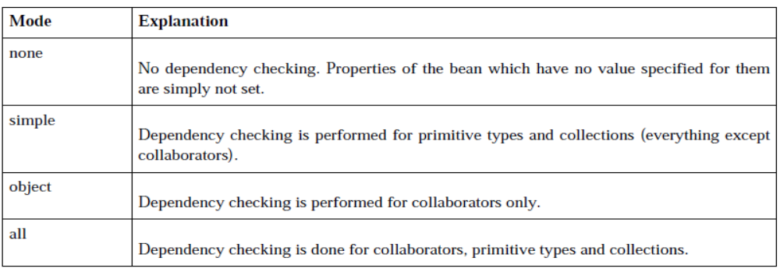

Bean scopes
When you create a bean definition what you are actually creating is a recipe for creating actual instances of the class defined by that bean definition. The idea that a bean definition is a recipe is important, because it means that, just like a class, you can potentially have many object instances created from a single recipe.

Scope | Description
singleton | Scopes a single bean definition to a single object instance per Spring IoC container.
prototype | Scopes a single bean definition to any number of object instances.
request | Scopes a single bean definition to the lifecycle of a single HTTP request; that is each and every HTTP request will have its own instance of a bean created off the back of a single bean definition. Only valid in the context of a web-aware Spring  ApplicationContext.
session | Scopes a single bean definition to the lifecycle of a HTTP Session. Only valid in the context of a web-aware Spring ApplicationContext.
global session | Scopes a single bean definition to the lifecycle of a global HTTP Session. Typically only valid when used in a portlet context. Only valid in the context of a web-aware Spring ApplicationContext.

Spring DAO – JDBC Support

Virtually all of today’s databases can be used from Java. Java code accesses the database using a JDBC driver (see http://java.sun.com/javase/technologies/database/). The driver translates JDBC operations to commands that the database can understand. The driver needs to be able to handle core JDBC concepts; for Spring’s JDBC support to be considered complete, it too must support all JDBC operations.
The JDBC framework is very complex, but at the highest level, you should understand that it contains the driver, the DriverManager, the connection, various types of statements, and finally the ResultSet.

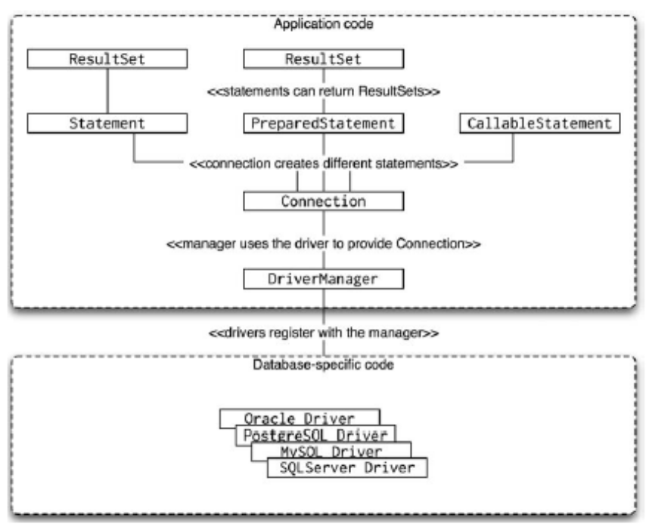
public class ConnectionDemo {
private static final String CONNECTION_STRING = "jdbc:oracle:thin:@dbServer:1521:ORCL";
public static void main(String[] args) {
try {
Class.forName("oracle.jdbc.OracleDriver");
} catch (ClassNotFoundException e) {
return;
}
Connection connection;
try {
connection = DriverManager.getConnection(CONNECTION_STRING,"scott", "tiger");
} catch (SQLException e) {
return;
}
// work with the connection
try {
connection.commit();
} catch (SQLException e) {
return;
}
try {
connection.close();
} catch (SQLException e) {
}
}
}
As you can see, the code is not very difficult; the only complexity comes from handling the various checked exceptions. We have left all the exception handling code in place just to demonstrate how cumbersome the code can become. Spring hides these details of the JDBC framework and provides a translation layer between JDBC exceptions and Spring unchecked exceptions.

Spring supports all the basic JDBC operations you have seen in this short introduction and adds elegant exception handling and connection management. Spring JDBC support simplifies all of the JDBC operations. Simplification does not mean that Spring hides the details, just that it contains all the boilerplate code so you can focus on the actual database code you need to implement.

Spring JDBC Templates
- Fine-grained templates
  - JdbcTemplate
  - NamedParameterJdbcTemplate
- Coarse-grained templates
  - SimpleJdbcTemplate
  - SimpleJdbcInsert
  - SimpleJdbcCall
- SQL objects
  - SqlUpdate
  - MappingSqlQuery

Spring Data Access Support

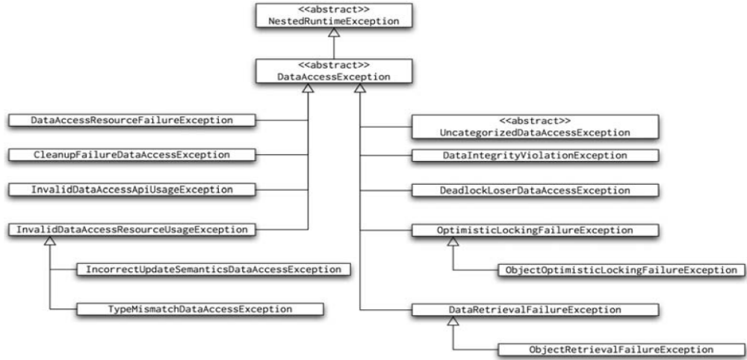
Figure : Exception hierarchy in Spring data support
Notice that all these exceptions are runtime exceptions, which make much more sense than the checked exceptions used in JDBC. Checked exceptions should be used to indicate an error that the application can recover from. But how can you recover from an exception caused by a malformed SQL statement?
Alongside the rich exception hierarchy, all Spring data access code follows the same pattern as HibernateTemplate, JdoTemplate, and JpaTemplate. All of these classes maintain the safety of the underlying scarce resources (e.g., database connections or Hibernate sessions). Spring also provides convenience superclasses for your data access implementations; their names are JdbcDaoSupport, HibernateDaoSupport, JdoDaoSupport, and JpaDaoSupport.

JDBC Data Access Support
JdbcTemplate allows you to work directly with instances of the Statement, PreparedStatement, and CallableStatement classes. The JdbcTemplate helps manage the connection and translates any SQLException to a Spring data access exception.

A DataSource is a JDBC interface that represents an alternative to DriverManager. Because it is an interface, many different implementations exist, from simple ones that just use the JDBC driver to get a connection to advanced pooling implementations.

Definition of the DataSource Bean
<?xml version="1.0" encoding="UTF-8"?>
<beans xmlns="...">
<bean id="dataSource" class="org.apache.commons.dbcp.BasicDataSource" destroy-method="close">
<property name="driverClassName" value="oracle.jdbc.driver.OracleDriver"/>
<property name="url" value="jdbc:oracle:thin:@dbServer:1521:ORCL"/>
<property name="username" value="scott"/>
<property name="password" value="tiger"/>
</bean>
</beans>

You can choose between two main approaches to writing JDBC data access code in Spring: you can either use the JdbcTemplate class, or you can use subclasses of the RdbmsOperation class. The JdbcTemplate offers features that allow you to do everything from just running a hard-coded SQL statement to complexly creating the statement, setting its parameters, and extracting results. Use the RdbmsOperation subclasses to create fine-grained implementations, each of which performs a specialized task.

The JdbcTemplate class is at the core of Spring JDBC support. Using the JdbcTemplate, you can perform call, execute, query, and update operations on the database. Each of these operations has a number of variations, which differ in the number of arguments and the return types of the JdbcTemplate methods.

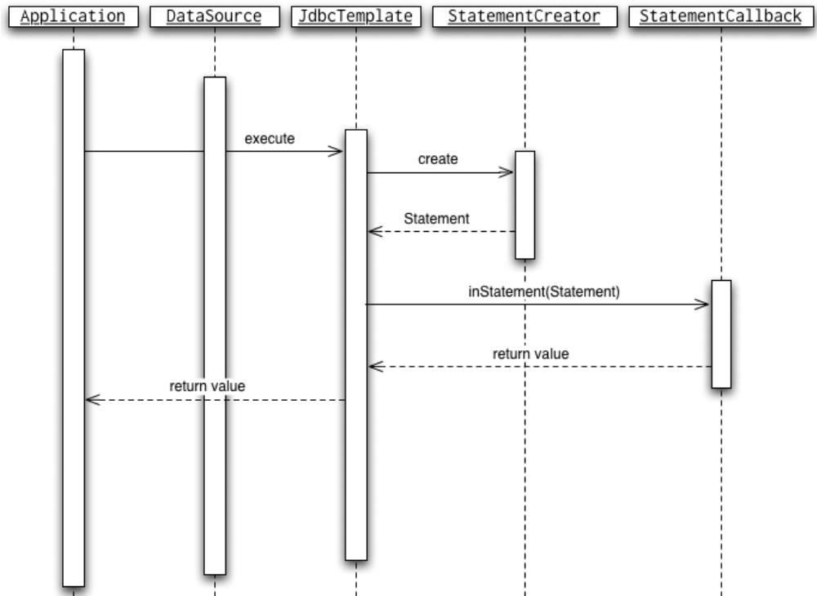
The JdbcTemplate uses the DataSource to obtain a connection (step 1). Then, it calls the StatementCreator instance to create the statement to be executed (steps 2 and 3). Next, it calls the StatementCallback to perform step 4. Once the StatementCallback returns the result, the JdbcTemplate performs all necessary housekeeping to close the connection (steps 4 through 8). If StatementCreator or the StatementCallback throw exceptions, the JdbcTemplate class catches them and translates them to Spring data access exceptions.

JdbcTemplate.execute
- Object execute(ConnectionCallback): This performs the code in ConnectionCallback. doInConnection and returns the value returned from the callback. Use this execute overload to perform data structure modifications using more than one statement. It is a bit too low-level to use for simple queries.
- Object execute(StatementCallback): This method performs the callback in StatementCallback. doInStatement and returns the value returned from the callback. Use this overload to perform operations on a single statement obtained from the connection. Use this operation in situations similar to execute(ConnectionCallback), but where you need only one statement.
- void execute(String): This execute overload is the simplest one: it performs a single statement using the String argument supplied. You can use this overload whenever you need to execute a single statement and are not interested in the result.
- Object execute(PreparedStatementCreator, PreparedStatementCallback): Performs the code in PreparedStatementCallback.doInPreparedStatement. The argument in this callback is the PreparedStatement returned from the PreparedStatementCreator.createPreparedStatement (Connection) method. This overload is best used when you have an implementation of PreparedStatementCreator and PreparedStatementCallback not as an anonymous implementation but as a reusable class.
- Object execute(String, PreparedStatementCallback): This overload is similar to the previous one, except it creates the PreparedStatement from the String argument. It executes the PreparedStatementCallback.doInPreparedStatement when the PreparedStatement is created.
- Object execute(CallableStatementCreator, CallableStatementCallback): This overload behaves exactly like the execute(PreparedStatementCreator, PreparedStatementCallback); the only difference is that it operates on callable statements. It can therefore execute stored procedures and functions. Again, this overload is commonly used when you have implementations of the CallableStatementCreator and CallableStatementCallback as reusable classes rather than anonymous implementations.
- Object execute(String, CallableStatementCallback3): The final overload of the execute method creates the CallableStatement from the first String argument, and once created, it invokes the CallableStatementCallback to process the result.

create or replace procedure p_actstartled(n number)
is
begin
dbms_output.put_line(n || '?! Really?');
end;
/
create or replace function f_calculate
return number
as
begin
return 42;
end;
/

jdbcdao-context.xml
<?xml version="1.0" encoding="UTF-8"?>
<beans xmlns="...">
<bean id="dataSource"
class="org.apache.commons.dbcp.BasicDataSource" destroy-method="close">
<property name="driverClassName" value="oracle.jdbc.driver.OracleDriver"/>
<property name="url" value="jdbc:oracle:thin:@dbServer:1521:orcl"/>
<property name="username" value="scott"/>
<property name="password" value="tiger"/>
</bean>
<bean id="jdbcTemplate" class="org.springframework.jdbc.core.JdbcTemplate">
<property name="dataSource" ref="dataSource"/>
</bean>
<bean id="jdbcTemplateDemo" class="com.JdbcTemplateDemo">
<property name="jdbcTemplate" ref="jdbcTemplate"/>
</bean>
</beans>

JdbcTemplateDemo.java
package com;

class JdbcTemplateDemo {
private JdbcTemplate jdbcTemplate;
private static class MyPreparedStatementCreator implements PreparedStatementCreator {
public PreparedStatement createPreparedStatement(Connection connection) throws SQLException {
PreparedStatement ps = connection.prepareStatement("select * from emp where empno=?");
ps.setLong(1, 1L);
return ps;
}
}

private static class MyPreparedStatementCallback implements PreparedStatementCallback {
public Object doInPreparedStatement(PreparedStatement preparedStatement) throws SQLException, DataAccessException {
ResultSet rs = preparedStatement.executeQuery();
List<Long> ids = new LinkedList<Long>();
while (rs.next()) {
ids.add(rs.getLong(1));
}
rs.close();
return ids;
}
}

private static class MyCallableStatementCreator implements CallableStatementCreator {
public CallableStatement createCallableStatement(Connection connection) throws SQLException {
CallableStatement cs = connection.prepareCall("{? = call f_calculate}");
cs.registerOutParameter(1, Types.INTEGER);
return cs;
}
}

private static class MyCallableStatementCallback implements CallableStatementCallback {
public Object doInCallableStatement(CallableStatement callableStatement) throws SQLException, DataAccessException {
callableStatement.execute();
return callableStatement.getLong(1);
}
}

private void run() {
this.jdbcTemplate.execute(new ConnectionCallback() {
public Object doInConnection(Connection connection) throws SQLException, DataAccessException {
PreparedStatement createTable = connection.prepareStatement(
"create table emp (empno number(19,0) not null, " +
"constraint pk_x primary key(empno))");
createTable.execute();
return null;
}
});

this.jdbcTemplate.execute(new StatementCallback() {
public Object doInStatement(Statement statement) throws SQLException, DataAccessException {
return statement.execute("insert into emp (empno) values (1)");
}
});

this.jdbcTemplate.execute("insert into emp (empno) values (2)");

List<Long> empnos = (List<Long>) this.jdbcTemplate.execute(
new MyPreparedStatementCreator(),
new MyPreparedStatementCallback());
System.out.println(empnos);
ids = (List<Long>) this.jdbcTemplate.execute("select empno from emp", new MyPreparedStatementCallback());
System.out.println(empnos);

System.out.println(this.jdbcTemplate.execute(
new MyCallableStatementCreator(),
new MyCallableStatementCallback()));
this.jdbcTemplate.execute("{call p_actstartled(42)}",
new CallableStatementCallback() {
public Object doInCallableStatement(
CallableStatement callableStatement)
throws SQLException, DataAccessException {
callableStatement.execute();
return null;
}
});
this.jdbcTemplate.execute("drop table emp");
}

public static void main(String[] args) {
ApplicationContext ac = new ClassPathXmlApplicationContext("jdbcdao-context.xml",JdbcTemplateDemo.class);
JdbcTemplateDemo demo = (JdbcTemplateDemo) ac.getBean("jdbcTemplateDemo");
demo.run();
}
public void setJdbcTemplate(JdbcTemplate jdbcTemplate) {
this.jdbcTemplate = jdbcTemplate;
}
}

RdbmsOperation Subclasses
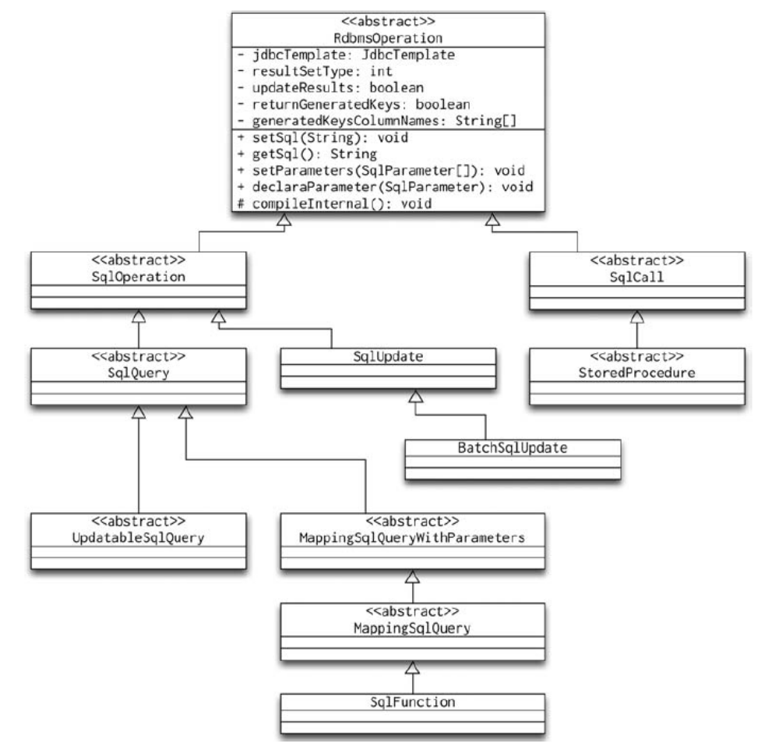
The RdbmsOperation abstract class is the root of a hierarchy of classes that let you write specialized subclasses to perform specific operations (update, insert, delete, and select). The hierarchy is split into two main paths: the SqlCall hierarchy, which represents statements that do not return results (other than output parameters in a stored procedure) and the SqlOperation hierarchy, which deals with statements that return results. It is also noteworthy that the RdbmsOperation class uses the JdbcTemplate internally.

SqlUpdate
As you can probably guess, this class is used to run SQL updates; again, by “update” we mean insert, update, or delete. We will begin by implementing an insert operation using the SqlUpdate.
class SqlUpdateDemo {
private Insert insert;
private static class Insert extends SqlUpdate {
private static final String SQL =
"insert into customer (id, first_name, last_name, last_login, comments) values (?, ?, ?, ?, ?)";
Insert(DataSource dataSource) {
super(dataSource, SQL); // 2
declareParameter(new SqlParameter(Types.INTEGER)); // 3.1
declareParameter(new SqlParameter(Types.VARCHAR)); // 3.2
declareParameter(new SqlParameter(Types.VARCHAR)); // 3.3
declareParameter(new SqlParameter(Types.TIMESTAMP)); // 3.4
declareParameter(new SqlParameter(Types.CLOB)); // 3.5
}
}
SqlUpdateDemo(DataSource dataSource) {
this.insert = new Insert(this.dataSource); // 1
}
private void runInsert() {
this.insert.update(new Object[] { 3L, "J", "Machacek", null, null }); // 4
this.insert.update(new Object[] { 4L, "J", "Doe", null, null }); // 5
}
public static void main(String[] args) {
ApplicationContext ac = new ClassPathXmlApplicationContext("jdbcdao-context.xml",SqlUpdateDemo.class);
SqlUpdateDemo me = new SqlUpdateDemo((DataSource)ac.getBean("dataSource"));
me.runInsert();
}
}

Using SqlQuery
class SqlQueryDemo {
private static final Log logger = LogFactory.getLog(SqlQueryDemo.class);
private static class SelectCustomer extends SqlQuery {
private static final String SQL = "select * from t_customer";
SelectCustomer(DataSource ds) {
super(ds, SQL);
}
protected RowMapper newRowMapper(Object[] parameters, Map context) {
return new ColumnMapRowMapper();
}
}
private SelectCustomer selectCustomer;
SqlQueryDemo(DataSource dataSource) {
this.selectCustomer = new SelectCustomer(dataSource);
}
public void run() {
List customers = this.selectCustomer.execute();
logger.debug(customers);
}
public static void main(String[] args) {
ApplicationContext ac = new ClassPathXmlApplicationContext(
"jdbcdao-context.xml",
SqlUpdateDemo.class);
SqlQueryDemo me = new SqlQueryDemo((DataSource)ac.getBean("dataSource"));
me.run();
}
}

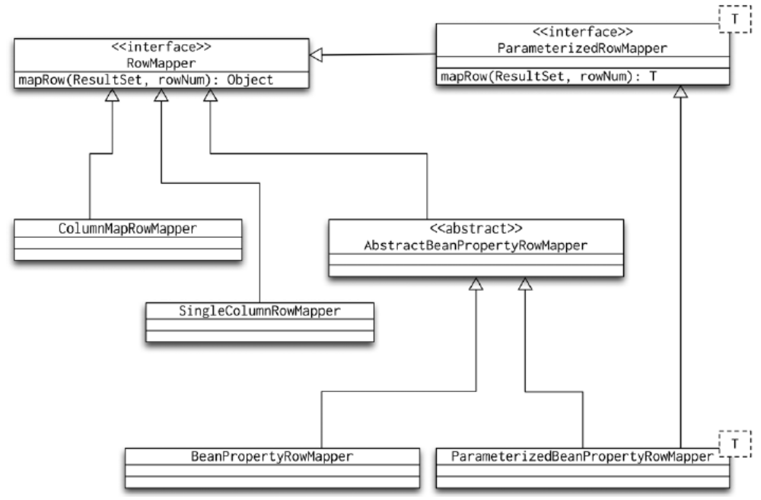

JdbcTemplate or RdbmsOperation?
Implementing the RdbmsOperation subclasses requires a bit more work than using the JdbcTemplate, so what is the benefit of doing this work? Remember the work the database has to do in order to execute a SQL statement: it must parse the statement to verify that it is syntactically correct, create an execution plan, and finally run the plan. The process of creating the execution plan can be difficult, especially if the SQL statement contains a large number of joins and the tables have a lot of indexes. The database examines statistics for each table and index to decide the best strategy to execute the statement. All this can be a lot of work, so most databases cache statements’ execution plans.
If you use the JdbcTemplate class, you create a new statement every time you call any of its methods, and only some databases would recognize that the repeated SQL code should be treated as the same statement. The RdbmsOperation subclasses keep their statements between executions, thus allowing the database to reuse the execution plan. Therefore, for high-performance operations, writing the specialized RdbmsOperation subclass is best. Another benefit is that the subclasses are usually very specific, allowing you to pass in parameters in a more elegant way than using an array of Object instances.

JdbcDaoSupport
You could use all the JDBC support classes we have introduced in any class in your application. However, it is very likely that you will only use them in your data access tier. That is why Spring comes with the convenience class JdbcDaoSupport. If you use this class as the superclass of your data access tier classes, you will be able to access the JdbcTemplate and the DataSource by calling the getJdbcTemplate and getDataSource methods. In addition, the JdbcDaoSupport implements InitializingBean, and even though it implements the afterPropertiesSet method as final, it provides an initDao method that you can override to perform any additional initialization code.
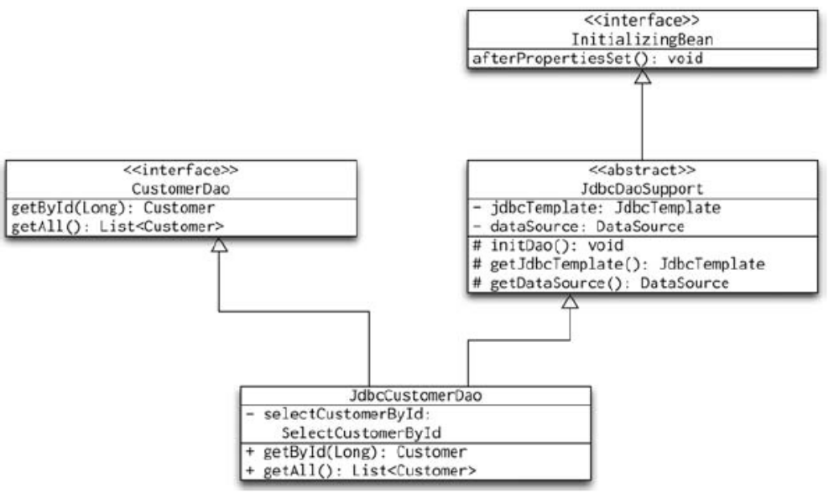

<?xml version="1.0" encoding="UTF-8"?>
<beans xmlns="http://www.springframework.org/schema/beans"
...>
<bean id="dataSource" class="org.apache.commons.dbcp.BasicDataSource"
destroy-method="close">
…
</bean>
<bean id="abstractJdbcDao" abstract="true"
class="org.springframework.jdbc.core.support.JdbcDaoSupport">
<property name="dataSource" ref="dataSource"/>
</bean>
<bean id="customerDao" class="com.JdbcCustomerDao" parent="abstractJdbcDao"/>
</beans>

public class JdbcCustomerDao extends JdbcDaoSupport implements CustomerDao {
private SelectCustomerById selectCustomerById;
private static class SelectCustomerById extends SqlQuery {
SelectCustomerById(DataSource ds) {
super(ds, "select * from customer where id=?");
declareParameter(new SqlParameter(Types.INTEGER));
}
protected RowMapper newRowMapper(Object[] parameters, Map context) {
return ParameterizedBeanPropertyRowMapper.newInstance(Customer.class);
}
}
@Override
protected void initDao() throws Exception {
this.selectCustomerById = new SelectCustomerById(getDataSource());
}
@SuppressWarnings({"unchecked"})
public List<Customer> getAll() {
return getJdbcTemplate().query("select * from t_customer",
ParameterizedBeanPropertyRowMapper.newInstance(Customer.class));
}
public Customer getById(long id) {
return (Customer)this.selectCustomerById.findObject(id);
}
}

Hibernate and Spring
The Spring Application Framework offers developers an environment that ties together numerous APIs into a coherent whole. Spring applies the philosophy of “dependency injection” by providing appropriate configurable wrapper classes for all sorts of popular Java libraries. The standard Spring API is immense, and its standardized approach to dependency management means that any existing API can in principle become a “Spring” API.

Hibernate
Hibernate provides a mapping of database columns to the objects by reading a configuration file. We define the mapping of our domain objects to the table columns in the XML configuration file. The configuration file for each of the mappings should have an extension of ".hbm.xml". Spring abstracts the framework one step more and provides us with classes like HibernateTemplate to access the database.

For example, let’sdefine our MOVIE object using hibernate mapping rules.
<hibernate-mapping>
<class name="com.domain.Movie" table="MOVIES">
<id name="id" column="ID">
<generator class="assigned"/>
</id>
<property name="title" column="TITLE"/>
<property name="genre" column="GENRE"/>
<property name="synopsis" column="SYNOPSIS"/>
</class>
</hibernate-mapping>
The class attribute defines the actual domain class, Movie in this case. The id attribute is the primary key and is assigned, meaning it is the application’s responsibility to set the primary key. The rest of the properties are mapped against the respective columns in the MOVIES table.
Hibernate requires a Session object in order to access the database. A Session is created from the SessionFactory. When using Spring framework, you can use LocalSession FactoryBean to create a SessionFactory. The LocalSessionFactoryBean requires a datasource to be wired in, along with hibernate properties and mapping resources. The hibernateProperties enables the properties such as database dialect, pool sizes, and other options. The mappingResources property loads the mapping config files (Movie.hbm.xml in our case)
<bean id="sessionFactory" class="org.springframework.orm.hibernate.LocalSessionFactoryBean">
<property name="dataSource" ref="movieDataSource"/>
<property name="hibernateProperties">
<props>
<prop key="hibernate.dialect">net.sf.hibernate.dialect.OracleDialect</prop>
<prop key="hibernate.show_sql">false</prop>
</props>
</property>
<property name="mappingResources">
<list>
<value>Movie.hbm.xml</value>
</list>
</property>
<bean id="movieDataSource" class="org.apache.commons.dbcp.BasicDataSource" destroy-method="close">
...
</bean>
</bean>

Now that the sessionFactory is defined, the next bit is to define HibernateTemplate. The HibernateTemplate requires a SessionFactory instance, so the following declaration wires the sessionFactory we defined earlier.
<bean id="hibernateTemplate" class="org.springframework.orm.hibernate.HibernateTemplate">
<property name="sessionFactory" ref="sessionFactory"/>
</bean>
<bean id="movieDao" class="com.dao.MovieDAO">
<property name="hibernateTemplate" ref="hibernateTemplate"/>
</bean>
The configuration is completed. Let’s implement a few methods for retrieving the data.
The getMovie method shown below uses the template’s load method.
public Movie getMovie(String id){
return (Movie)getHibernateTemplate().load (Movie.class, id);
}

As you can see, there’s no SQL that retrieves a movie in this method. We can feel that we are working with Java objects rather than data! The load method accesses the database to load the matching row based on the id passed. Updating a Movie is simple as well:
public void updateMovie(Movie m){
getHibernateTemplate().update (m);
}
As you can see, the single statement above will do the job! Deleting a row is as simple as invoking the delete method.
public void deleteMovie(Movie m){
getHibernateTemplate().delete (m);
}
Running queries is straightforward, too. Hibernate introduces Hibernate Query Language (HQL) for writing queries. Use find methods to execute the queries. For example, returning a Movie based on a ID is shown below:
public Movie getMovie(String id){
return (Movie)getHibernateTemplate().find("from MOVIES as movies
where movies.id=?",id);
}

Configuring Hibernate from a Spring Application
A conventional Hibernate application needs access to its database and the entity mapping information. The point of access to a fully configured Hibernate environment is the session factory, from which Session objects are obtained. Spring provides a bean to represent the session factory, but provides a few additional options in order to configure its resources.

hibernate.cfg.xml
<?xml version='1.0' encoding='utf-8'?>
<!DOCTYPE hibernate-configuration PUBLIC
"-//Hibernate/Hibernate Configuration DTD//EN"
"http://hibernate.sourceforge.net/hibernate-configuration-3.0.dtd">

<hibernate-configuration>
<session-factory>
<property name="connection.driver_class">
oracle.jdbc.OracleDriver
</property>
<property name="connection.url">
jdbc:oracle:thin:@localhost:1521:orcl
</property>
<property name="connection.username">scott</property>
<property name="connection.password">tiger</property>
<property name="hibernate.connection.pool_size">0</property>
<property name="show_sql">true</property>
<property name="dialect">org.hibernate.dialect.OracleDialect</property>
<mapping class="com.Paper"/>
<mapping class="com.Article"/>
</session-factory>
</hibernate-configuration>

Configuring Spring
<bean id="sessionFactory" class="org.springframework.orm.hibernate3.LocalSessionFactoryBean">
<property name="configurationClass" value="org.hibernate.cfg.AnnotationConfiguration" />
<property name="configLocation" value="classpath:hibernate.cfg.xml" />
</bean>

Spring represents the configured session factory as an org.springframework.orm.hibernate3.LocalSessionFactoryBean. Spring allows data sources to be managed centrally as beans, and if a JndiObjectFactoryBean bean is used, it can in turn draw its details from JNDI. The LocalSessionFactoryBean therefore provides a dataSource property into which the appropriate Spring DataSource bean can be injected. Typically, to manage a data source from within the Spring configuration, but without deferring the details to a JNDI resource, you would use the DriverManagerDataSource bean.

Configuring a Typical BasicDataSource Bean
<bean id="sampleDataSource"
class="org.springframework.jdbc.datasource.DriverManagerDataSource"
destroy-method="close">
<property name="driverClassName">
<value>oracle.jdbc.OracleDriver</value>
</property>
<property name="url">
<value>
jdbc:oracle:thin:@localhost:1521:orcl
</value>
</property>
<property name="username" value="scott"/>
<property name="password" value="tiger"/>
</bean>
Alternatively, if the data source resources are to be drawn from an existing JNDI-accessible data source, then the Spring JndiObjectFactoryBean should be used to represent the data source

Configuring a Typical JndiObjectFactoryBean
<bean id="sampleDataSource" class="org.springframework.jndi.JndiObjectFactoryBean">
<property name="jndiName" value="java:comp/env/jdbc/spring"/>
</bean>

Configuring Hibernate Purely from Spring
<bean id="sampleSessionFactory"
class="org.springframework.orm.hibernate3.LocalSessionFactoryBean">
<property name="dataSource" ref="sampleDataSource"/>
<property name="mappingResources">
<list>
<value>com/Paper.hbm.xml</value>
<value>com/Article.hbm.xml</value>
</list>
</property>
<property name="hibernateProperties">
<props>
<prop key="hibernate.connection.pool_size">0</prop>
<prop key="hibernate.show_sql">true</prop>
<prop key="hibernate.dialect">org.hibernate.dialect.OracleDialect</prop>
</props>
</property>
</bean>

Using Hibernate in Spring Beans
With your session factory configured as a Spring bean, you can now go on to create DAOs that take advantage of Hibernate’s functionality. Previous versions of Spring and Hibernate required the use of the HibernateDaoSupport class and/or HibernateTemplate class to form the basis of your DAOs; however, recent versions of Spring and Hibernate have eliminated the need for these classes. Hibernate now supports a getCurrentSession() method on the SessionFactory that returns a Session object that is associated with the current transaction. Ideally, you should define an interface to specify the methods that your DAO will contain.

package com.dao;
import java.util.List;
import com.hibernatebook.spring.Article;
import com.hibernatebook.spring.Paper;
public interface PaperDao {
public List<Paper> getAll();
public void createPaper(final Paper paper);
public Paper getPaper(final Integer paperId);
public Paper createArticle(final Integer paperId,final Article article);
}

Implementing getAll() Inside a Spring/Hibernate 3 DAO
@SuppressWarnings("unchecked")
public List<Paper> getAll() {
Session session = this.sessionFactory.getCurrentSession();
List<Paper> papers = (List<Paper>)session.createQuery("from Paper").list();
return papers;
}

Regardless of how you use it, configuring your Spring/Hibernate 3 DAO is extremely simple. The basic requirement is that you provide its sessionFactory property with a session factory bean from which to obtain Hibernate Session objects

Configuring a Spring/Hibernate 3 DAO

<bean id="sampleDao" class="com.hibernatebook.spring.dao.PaperDaoImpl">
<property name="sessionFactory" ref="sessionFactory"/>
</bean>

Spring MVC Framework
Spring MVC is one of the most important modules of the Spring framework. It builds on the powerful Spring IoC container and makes extensive use of the container features to simplify its configuration. Most Spring MVC configurations are written in bean configuration files.

Model-view-controller (MVC) is a common design pattern in UI design. It decouples business logic from UIs by separating the roles of model, view, and controller in an application. Models are responsible for encapsulating application data for views to present. Views should only present this data, without including any business logic. Controllers are responsible for receiving requests from users and invoking back-end services for business processing. After processing, back-end services may return some data for views to present. Controllers collect this data and prepare models for views to present. The core idea of the MVC pattern is to separate business logic from UIs to allow them to change independently without affecting each other.

In Spring 2.0 and prior versions, controllers have to extend one of Spring’s controller classes. In Spring 2.5, controllers can be arbitrary Java objects annotated with Spring’s controller annotations. Controllers have to interact with service layer components for business processing, which often have transaction management enabled.

Developing a Simple Web Application with Spring MVC

The central component of Spring MVC is DispatcherServlet. As its name indicates, it mainly dispatches requests to appropriate handlers for them to handle the requests. It is the only servlet you need to configure in the web deployment descriptor. DispatcherServlet implements one of Sun’s core Java EE design patterns called front controller. It acts as the front controller of the Spring MVC framework, and every web request must go through it so that it can manage the entire request-handling process.
When a web request is sent to a Spring MVC application, DispatcherServlet will first receive the request. Then it will organize different components configured in Spring’s web application context to handle this request.

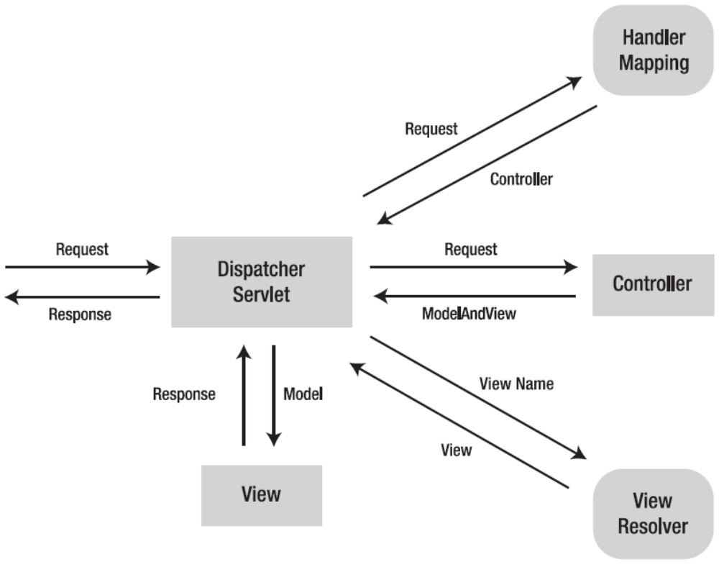
When DispatcherServlet receives a request, it will first look for an appropriate handler to handle the request. DispatcherServlet maps each request to a handler by one or more handler mappings. A handler mapping is a bean configured in the web application context that implements the HandlerMapping interface. It is responsible for returning an appropriate handler for a request. Handler mappings usually map a request to a handler according to the request’s URL.

Once DispatcherServlet has picked an appropriate handler, it will invoke this handler to handle the request. A handler is an arbitrary Java object that can handle web requests. The most typical handler used in Spring MVC for handling web requests is a controller. Usually, a controller has to invoke back-end services for request handling.

After a controller has finished handling the request, it returns a model and a view name, or sometimes a view object, to DispatcherServlet. The model contains the attributes that the controller wants to pass to the view for display. If a view name is returned, it will be resolved into a view object for rendering. The basic class that binds a model and a view is ModelAndView.
When DispatcherServlet receives a model and a view name, it will resolve the logical view name into a view object for rendering. DispatcherServlet resolves views from one or more view resolvers. A view resolver is a bean configured in the web application context that implements the ViewResolver interface. Its responsibility is to return a view object for a logical view name.
Once DispatcherServlet has resolved a view name into a view object, it will render the view object and pass in the model returned by the controller. The view’s responsibility is to display the model attributes to the user.

Configuration Files
web.xml
<web-app version="2.4" xmlns="http://java.sun.com/xml/ns/j2ee"
xmlns:xsi="http://www.w3.org/2001/XMLSchema-instance"
xsi:schemaLocation="http://java.sun.com/xml/ns/j2ee
http://java.sun.com/xml/ns/j2ee/web-app_2_4.xsd">
<display-name>Sping MVC Application</display-name>
<servlet>
<servlet-name>dispatcher</servlet-name>
<servlet-class>
org.springframework.web.servlet.DispatcherServlet
</servlet-class>
<load-on-startup>1</load-on-startup>
</servlet>
<servlet-mapping>
<servlet-name>dispatcher</servlet-name>
<url-pattern>*.htm</url-pattern>
</servlet-mapping>
</web-app>

Another purpose of the servlet name is for DispatcherServlet to decide which file to load for Spring MVC configurations. By default, it will look for a file by joining the servlet name with -servlet.xml as the file name. You can explicitly specify a configuration file in the contextConfigLocation servlet parameter.With the preceding setting, the dipatcher servlet will load the Spring MVC configuration file dispatcher-servlet.xml by default. This file should be a standard Spring bean configuration file, as shown following:
<beans xmlns="http://www.springframework.org/schema/beans"
xmlns:xsi="http://www.w3.org/2001/XMLSchema-instance"
xsi:schemaLocation="http://www.springframework.org/schema/beans
http://www.springframework.org/schema/beans/spring-beans-2.5.xsd">
...
</beans>

Later, you will configure Spring MVC with a series of Spring beans declared in this configuration file. You may also declare other application components such as data access objects and service objects in this file. However, it’s not a good practice to mix beans of different layers in a single configuration file. Instead, you should declare one bean configuration file per layer
(e.g., court-persistence.xml for the persistence layer and court-service.xml for the service layer). For example, court-service.xml should include the following service object:
<beans xmlns="http://www.springframework.org/schema/beans"
xmlns:xsi="http://www.w3.org/2001/XMLSchema-instance"
xsi:schemaLocation="http://www.springframework.org/schema/beans
http://www.springframework.org/schema/beans/spring-beans-2.5.xsd">
<bean id="reservationService"
class="com.court.service.ReservationServiceImpl" />
</beans>

In order for Spring to load your configuration files besides court-servlet.xml, you need to define the servlet listener ContextLoaderListener in web.xml. By default, it loads the bean configuration file /WEB-INF/applicationContext.xml, but you can specify your own in the context parameter contextConfigLocation. You can specify multiple configuration files by separating their locations with either commas or spaces.
<web-app ...>
<context-param>
<param-name>contextConfigLocation</param-name>
<param-value>/WEB-INF/court-service.xml</param-value>
</context-param>
<listener>
<listener-class>
org.springframework.web.context.ContextLoaderListener
</listener-class>
</listener>
...
</web-app>

Note that ContextLoaderListener loads the specified bean configuration files into the root application context, while each DispatcherServlet instance loads its configuration file into its own application context and refers to the root application context as its parent. So, the context loaded by each DispatcherServlet instance can access and even override beans declared in the root application context (but not vice versa). However, the contexts loaded by the DispatcherServlet instances cannot access each other.

Spring MVC Controllers
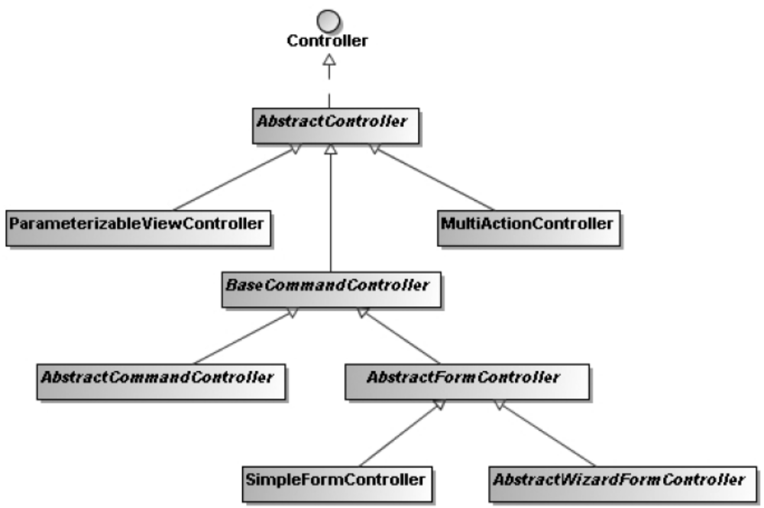

The Controller interface is the base interface for all the controller classes in Spring MVC. You can create your own controller by implementing this interface. In the handleRequest() method, you are free to handle a web request just as you do in a servlet. Finally, you have to return a ModelAndView object that includes a view name or a view object, and some model attributes.

package com.court.web;
...
import javax.servlet.http.HttpServletRequest;
import javax.servlet.http.HttpServletResponse;
import org.springframework.web.servlet.ModelAndView;
import org.springframework.web.servlet.mvc.Controller;
public class WelcomeController implements Controller {
public ModelAndView handleRequest(HttpServletRequest request,
HttpServletResponse response) throws Exception {
Date today = new Date();
return new ModelAndView("welcome", "today", today);
}
}

This controller simply creates a java.util.Date object to retrieve the current date, and then returns a ModelAndView object including the view name welcome and the current date as a model attribute for the target view to display.

After you create a controller class, you have to declare its instance in the web application context. As this is a presentation layer component, you should declare it in court-servlet.xml. By default, DispatcherServlet uses BeanNameUrlHandlerMapping as its default handler mapping if you don’t configure one explicitly. This handler mapping maps requests to handlers according to the URL patterns specified in the bean names of the handlers. As a <bean> element’s id attribute cannot contain the / character, you should use the name attribute instead.
<bean name="/welcome.htm"
class="com.court.web.WelcomeController" />

If you would like your controller to have some basic controller features like filtering the supported HTTP methods (GET, POST, and HEAD) and generating the cache-control header in HTTP responses, you can have it extend the AbstractController class, which implements the Controller interface. Note that the method you have to override in this controller class is handleRequestInternal().

package com.court.web;
...
import org.springframework.web.servlet.mvc.AbstractController;
public class WelcomeController extends AbstractController {
public ModelAndView handleRequestInternal(HttpServletRequest request,
HttpServletResponse response) throws Exception {
Date today = new Date();
return new ModelAndView("welcome", "today", today);
}
}

<bean name="/welcome.htm"
class="com.court.web.WelcomeController">
<property name="supportedMethods" value="GET" />
<property name="cacheSeconds" value="60" />
</bean>

For example, you can set a controller’s supported HTTP methods in the supportedMethods property, with commas as separators. If an HTTP request’s method is not in this list, a ServletException will be thrown. You can also define the cache seconds for a controller so that it will be set in an HTTP response’s header. A typical controller may accept HTTP request parameters and invoke back-end services for business processing.

package com.court.web;
...
import javax.servlet.http.HttpServletRequest;
import javax.servlet.http.HttpServletResponse;
import org.springframework.web.bind.ServletRequestUtils;
import org.springframework.web.servlet.ModelAndView;
import org.springframework.web.servlet.mvc.AbstractController;
public class ReservationQueryController extends AbstractController {
private ReservationService reservationService;
public void setReservationService(ReservationService reservationService) {
this.reservationService = reservationService;
}
public ModelAndView handleRequestInternal(HttpServletRequest request,
HttpServletResponse response) throws Exception {
String courtName =
ServletRequestUtils.getStringParameter(request, "courtName");
Map<String, Object> model = new HashMap<String, Object>();
if (courtName != null) {
model.put("courtName", courtName);
model.put("reservations", reservationService.query(courtName));
}
return new ModelAndView("reservationQuery", model);
}
}

In this controller, you first retrieve the request parameter courtName from the request. You can make use of the standard Servlet API HttpServletRequest.getParameter() for this purpose, but Spring supplies more convenient static methods in the ServletRequestUtils class for you to retrieve request parameters of converted types and also required parameters. This can save you the trouble of performing conversion and checking. When you have more than one model attribute to pass to the view, you can store them in a map and pass this map to the constructor of ModelAndView.

<bean name="/reservationQuery.htm"
class="com.court.web.ReservationQueryController">
<property name="reservationService" ref="reservationService" />
</bean>

JSP Views
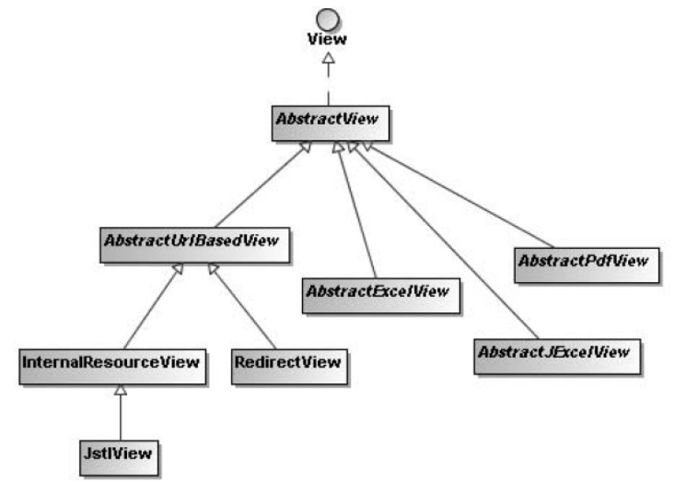

In a Spring MVC application, views are most commonly JSP templates written with JSTL. When DispatcherServlet receives a view name returned from a handler, it will resolve the logical view name into a view object for rendering. For example, you can configure an InternalResourceViewResolver bean in the web application context to resolve view names into JSP files in the /WEB-INF/jsp/ directory:
<bean class="org.springframework.web.servlet.view.InternalResourceViewResolver">
<property name="prefix" value="/WEB-INF/jsp/" />
<property name="suffix" value=".jsp" />
</bean>
Then you can create the following JSP template for the welcome controller. You can name it welcome.jsp and put it in the /WEB-INF/jsp/ directory:
<%@ taglib prefix="fmt" uri="http://java.sun.com/jsp/jstl/fmt" %>
<html>
<head>
<title>Welcome</title>
</head>
<body>
<h2>Welcome to Court Reservation System</h2>
Today is <fmt:formatDate value="${today}" pattern="yyyy-MM-dd" />.
</body>
</html>

In this JSP template, you make use of the fmt tag library in JSTL to format the today model attribute into the pattern yyyy-MM-dd. Don’t forget to include the fmt tag library definition at the top of this JSP template.
Next, you can create another JSP template for the reservation query controller and name it reservationQuery.jsp to match the view name:
<%@ taglib prefix="c" uri="http://java.sun.com/jsp/jstl/core" %>
<%@ taglib prefix="fmt" uri="http://java.sun.com/jsp/jstl/fmt" %>
<html>
<head>
<title>Reservation Query</title>
</head>
<body>
<form method="POST">
Court Name
<input type="text" name="courtName" value="${courtName}" />
<input type="submit" value="Query" />
</form>
<table border="1">
<tr>
<th>Court Name</th>
<th>Date</th>
<th>Hour</th>
<th>Player</th>
</tr>
<c:forEach items="${reservations}" var="reservation">
<tr>
<td>${reservation.courtName}</td>
<td><fmt:formatDate value="${reservation.date}" pattern="yyyy-MM-dd" /></td>
<td>${reservation.hour}</td>
<td>${reservation.player.name}</td>
</tr>
</c:forEach>
</table>
</body>
</html>
In this JSP template, you include a form for users to input the court name they want to query, and then use the <c:forEach> tag to loop the reservations model attribute to generate the result table.

<Context docBase="c:/eclipse/workspace/Court/court" />
By default, Tomcat listens on port 8080 and uses the context descriptor’s name (court in this case) as the context path, so the welcome controller and the reservation query controller can be accessed through the following URLs:

http://localhost:8080/court/welcome.htm
http://localhost:8080/court/reservationQuery.htm

Mapping Requests to Handlers
In a Spring MVC application, web requests are mapped to handlers by one or more handler mapping beans declared in the web application context. These beans have to implement the HandlerMapping interface for DispatcherServlet to auto-detect them. Spring MVC comes with several HandlerMapping implementations for you to map requests using different strategies. By default, if you don’t have a handler mapping configured explicitly, DispatcherServlet will use BeanNameUrlHandlerMapping as its default handler mapping, which maps requests to handlers according to the URL patterns specified in the bean names. So, if you are satisfied with this strategy, you don’t need to define your own handler mappings.
Handler mappings match URLs according to their paths relative to the context path (i.e., the web application context’s deployed path) and the servlet path (i.e., the path mapped to DispatcherServlet). So, for the URL http://localhost:8080/court/welcome.htm, the path to match is /welcome.htm, as the context path is /court and there’s no servlet path.

<beans ...>
...
<bean name="/welcome.htm"
class="com.court.web.WelcomeController">

...
</bean>
<bean name="/reservationQuery.htm"
class="com.court.web.ReservationQueryController">
...
</bean>
</beans>
When using this mapping strategy, you have to set a handler’s name via the name attribute, as the id attribute cannot contain the / character.

Mapping Requests by Controller Class Names
Another handler mapping provided by Spring is ControllerClassNameHandlerMapping, which generates handler mappings for handlers that implement the Controller interface. It generates mappings automatically according to the class names of the controllers declared in the web application context.
<beans ...>
...
<bean class="org.springframework.web.servlet.mvc.support.ControllerClassNameHandlerMapping" />
<bean class="com.court.web.WelcomeController">
...
</bean>
<bean class="com.court.web.ReservationQueryController">
...
</bean>
</beans>

For these bean declarations, ControllerClassNameHandlerMapping will generate the handler mappings automatically by removing the Controller suffix in the class name and converting the remaining part to lowercase.
WelcomeController → /welcome*
ReservationQueryController → /reservationquery*

However, if you want your URL patterns to follow the variable-naming convention in Java (e.g., generating /reservationQuery* instead of /reservationquery*), you have to set the caseSensitive property to true. Besides, you can specify a prefix for the generated URL patterns in the pathPrefix property. You can also specify the base package in the basePackage property, and then the subpackage relative to it will be included in the mapping.
<bean class="org.springframework.web.servlet.mvc.support.ControllerClassNameHandlerMapping">
<property name="caseSensitive" value="true" />
<property name="pathPrefix" value="/reservation" />
<property name="basePackage" value="com.court" />
</bean>
This ControllerClassNameHandlerMapping definition will generate the following handler mappings:
WelcomeController → /reservation/web/welcome*
ReservationQueryController → /reservation/web/reservationQuery*

Mapping Requests with Custom Mapping Definitions
The most straightforward and flexible strategy for mapping requests to handlers is to specify the mapping definitions between URL patterns and handlers explicitly.
<beans ...>
...
<bean class="org.springframework.web.servlet.handler.SimpleUrlHandlerMapping">
<property name="mappings">
<props>
<prop key="/welcome.htm">welcomeController</prop>
<prop key="/reservationQuery.htm">
reservationQueryController
</prop>
</props>
</property>
</bean>
<bean id="welcomeController" class="com.court.web.WelcomeController">
...
</bean>
<bean id="reservationQueryController" class="com.court.web.ReservationQueryController">
...
</bean>
</beans>
SimpleUrlHandlerMapping accepts the mapping definition as a Properties object. The property keys are the URL patterns while the property values are the handler IDs or names. The URL patterns can also accept wildcards for a handler to handle multiple URLs.

Mapping Requests by Multiple Strategies
In a web application with a large number of handlers, it is often insufficient to choose only one handler mapping strategy. Typically, ControllerClassNameHandlerMapping can satisfy most of the mappings. Usually, however, some of the mappings have to be mapped with SimpleUrlHandlerMapping explicitly. In this case, you have to combine both strategies for handler
mapping:
<beans ...>
...
<bean class="org.springframework.web.servlet.handler.SimpleUrlHandlerMapping">
<property name="mappings">
<props>
<prop key="/index.htm">welcomeController</prop>
<prop key="/main.htm">welcomeController</prop>
</props>
</property>
<property name="order" value="0" />
</bean>
<bean class="org.springframework.web.servlet.mvc.support.ControllerClassNameHandlerMapping">
<property name="caseSensitive" value="true" />
<property name="order" value="1" />
</bean>
</beans>

When choosing more than one strategy at the same time, it’s important to specify the mapping priority. You can set the order properties of the handler mapping beans for this purpose. The lower order value represents the higher priority. For these two handler mappings, web requests will be mapped to handlers as shown following:
/index.htm → WelcomeController
/main.htm → WelcomeController
/welcome* → WelcomeController
/reservationQuery* → ReservationQueryController

Intercepting Requests with Handler Interceptors
Spring MVC allows you to intercept web requests for pre-handling and post-handling through handler interceptors. Handler interceptors are configured in Spring’s web application context, so they can make use of any container features and refer to any beans declared in the container.
A handler interceptor is registered for particular handler mappings, so it will only intercept requests mapped by these handler mappings. Each handler interceptor must implement the HandlerInterceptor interface, which contains three callback methods for you to implement: preHandle(), postHandle(), and afterCompletion(). The first and second methods will be called before and after a request is handled by a handler. The second method also allows you to get access to the returned ModelAndView object, so you can manipulate the model attributes in it. The last method will be called after the completion of all request processing (i.e., after the view has been rendered).

package com.court.web;
...
import org.springframework.web.servlet.HandlerInterceptor;
import org.springframework.web.servlet.ModelAndView;
public class MeasurementInterceptor implements HandlerInterceptor {
public boolean preHandle(HttpServletRequest request,
HttpServletResponse response, Object handler) throws Exception {
long startTime = System.currentTimeMillis();
request.setAttribute("startTime", startTime);
return true;
}
public void postHandle(HttpServletRequest request,
HttpServletResponse response, Object handler,
ModelAndView modelAndView) throws Exception {
long startTime = (Long) request.getAttribute("startTime");
request.removeAttribute("startTime");
long endTime = System.currentTimeMillis();
modelAndView.addObject("handlingTime", endTime - startTime);
}
public void afterCompletion(HttpServletRequest request,
HttpServletResponse response, Object handler, Exception ex)
throws Exception {
}
}

In the preHandle() method of this interceptor, you record the start time and save it to a request attribute. This method should return true, allowing DispatcherServlet to proceed with request handling. Otherwise, DispatcherServlet assumes that this method has already handled the request, so DispatcherServlet will return the response to the user directly. Then, in the postHandle() method, you load the start time from the request attribute and compare it with the current time. You can calculate the total duration and then add this time to the model for passing to the view. Finally, as there is nothing for the afterCompletion() method to do, you can leave its body empty.
When implementing an interface, you must implement all the methods even though you may not have a need for all of them. A better way is to extend the interceptor adapter class instead. This class implements all the interceptor methods by default. You can override only the methods that you need.

package com.court.web;
...
import org.springframework.web.servlet.ModelAndView;
import org.springframework.web.servlet.handler.HandlerInterceptorAdapter;
public class MeasurementInterceptor extends HandlerInterceptorAdapter {
public boolean preHandle(HttpServletRequest request,
HttpServletResponse response, Object handler) throws Exception {
...
}
public void postHandle(HttpServletRequest request,
HttpServletResponse response, Object handler,
ModelAndView modelAndView) throws Exception {
...
}
}

A handler interceptor is registered to a handler mapping bean to intercept web requests mapped by this bean. You can specify multiple interceptors for a handler mapping in the interceptors property, whose type is an array. If you have more than one handler mapping configured in your web application context and you want to intercept all requests mapped by them, you must register this interceptor to each of them.
<beans ...>
...
<bean id="measurementInterceptor"
class="com.court.web.MeasurementInterceptor" />
<bean
class="org.springframework.web.servlet.handler.SimpleUrlHandlerMapping">
<property name="interceptors">
<list>
<ref bean="measurementInterceptor" />
</list>
</property>
...
</bean>
<bean class="org.springframework.web.servlet.mvc.support.å
ControllerClassNameHandlerMapping">
<property name="interceptors">
<list>
<ref bean="measurementInterceptor" />
</list>
</property>
...
</bean>
</beans>
Then you can show this time in welcome.jsp to verify this interceptor’s functionality. As WelcomeController doesn’t have much to do, you may likely see that the handling time is 0 milliseconds. If this is the case, you may add a sleep statement to this class to see a longer handling time.
<%@ taglib prefix="fmt" uri="http://java.sun.com/jsp/jstl/fmt" %>
<html>
<head>
<title>Welcome</title>
</head>
<body>
...
<hr />
Handling time : ${handlingTime} ms
</body>
</html>

Resolving User Locales
In a Spring MVC application, a user’s locale is identified by a locale resolver, which has to implement the LocaleResolver interface. Spring MVC comes with several LocaleResolver implementations for you to resolve locales by different criteria. Alternatively, you may create your own custom locale resolver by implementing this interface. You can define a locale resolver simply by registering a bean of type LocaleResolver in the web application context. You must set the bean name of the locale resolver to localeResolver for DispatcherServlet to auto-detect. Note that you can register only one locale resolver per DispatcherServlet.

Resolving Locales by an HTTP Request Header
The default locale resolver used by Spring is AcceptHeaderLocaleResolver. It resolves locales by inspecting the accept-language header of an HTTP request. This header is set by a user’s web browser according to the locale setting of the underlying operating system. Note that this locale resolver cannot change a user’s locale because it is unable to modify the locale setting of the user’s operating system.

Resolving Locales by a Session Attribute
Another option of resolving locales is by SessionLocaleResolver. It resolves locales by inspecting a predefined attribute in a user’s session. If the session attribute doesn’t exist, this locale resolver will determine the default locale from the accept-language HTTP header.
<bean id="localeResolver" class="org.springframework.web.servlet.i18n.SessionLocaleResolver">
<property name="defaultLocale" value="en" />
</bean>
You can set the defaultLocale property for this resolver in case the session attribute doesn’t exist. Note that this locale resolver is able to change a user’s locale by altering the session attribute that stores the locale.

Resolving Locales by a Cookie
You can also use CookieLocaleResolver to resolve locales by inspecting a cookie in a user’s browser. If the cookie doesn’t exist, this locale resolver will determine the default locale from the accept-language HTTP header.
<bean id="localeResolver" class="org.springframework.web.servlet.i18n.CookieLocaleResolver" />
The cookie used by this locale resolver can be customized by setting the cookieName and cookieMaxAge properties. The cookieMaxAge property indicates how many seconds this cookie should be persisted. The value -1 indicates that this cookie will be invalid after the browser is closed.
<bean id="localeResolver" class="org.springframework.web.servlet.i18n.CookieLocaleResolver">
<property name="cookieName" value="language" />
<property name="cookieMaxAge" value="3600" />
<property name="defaultLocale" value="en" />
</bean>

You can also set the defaultLocale property for this resolver in case the cookie doesn’t exist in a user’s browser. This locale resolver is able to change a user’s locale by altering the cookie that stores the locale.

Changing a User’s Locale
In addition to changing a user’s locale by calling LocaleResolver.setLocale() explicitly, you can also apply LocaleChangeInterceptor to your handler mappings. This interceptor will detect if a special parameter is present in the current HTTP request. The parameter name can be customized with the paramName property of this interceptor. If such a parameter is present in the current request, this interceptor will change the user’s locale according to the parameter value.
<beans ...>
...
<bean id="localeChangeInterceptor"
class="org.springframework.web.servlet.i18n.LocaleChangeInterceptor">
<property name="paramName" value="language" />
</bean>
<bean class="org.springframework.web.servlet.handler.SimpleUrlHandlerMapping">
<property name="interceptors">
<list>
...
<ref bean="localeChangeInterceptor" />
</list>
</property>
...
</bean>
<bean class="org.springframework.web.servlet.mvc.support.ControllerClassNameHandlerMapping">
<property name="interceptors">
<list>
...
<ref bean="localeChangeInterceptor" />
</list>
</property>
...
</bean>
</beans>
LocaleChangeInterceptor can only detect the parameter for the handler mappings that enable it. So, if you have more than one handler mapping configured in your web application context, you have to register this interceptor to all of them to allow users to change their locales in any of the URLs.
Now a user’s locale can be changed by any URLs with the language parameter. For example, the following two URLs change the user’s locale to English for the United States, and to German, respectively:

http://localhost:8080/court/welcome.htm?language=en_US
http://localhost:8080/court/welcome.htm?language=de
Then you can show the HTTP response object’s locale in welcome.jsp to verify the locale interceptor’s configuration:
<%@ taglib prefix="fmt" uri="http://java.sun.com/jsp/jstl/fmt" %>
<html>
<head>
<title>Welcome</title>
</head>
<body>
...
<br />
Locale : ${pageContext.response.locale}
</body>
</html>

Externalizing Locale-Sensitive Text Messages
To avoid creating different versions of a page for different locales, you should make your web page independent of the locale by externalizing locale-sensitive text messages. Spring is able to resolve text messages for you by using a message source, which has to implement the MessageSource interface. Then your JSP files can use the <spring:message> tag, defined in Spring’s tag library, to resolve a message given the code.

You can define a message source simply by registering a bean of type MessageSource in the web application context. You must set the bean name of the message source to messageSource for DispatcherServlet to auto-detect. Note that you can register only one message source per DispatcherServlet.
The ResourceBundleMessageSource implementation resolves messages from different resource bundles for different locales. For example, you can register it in court-servlet.xml to load resource bundles whose base name is messages:
<bean id="messageSource" class="org.springframework.context.support.ResourceBundleMessageSource">
<property name="basename" value="messages" />
</bean>

Then you create two resource bundles, messages.properties and messages_de.properties, to store messages for the default and German locales. These resource bundles should be put in the root of the classpath.
welcome.title=Welcome
welcome.message=Welcome to Court Reservation System
welcome.title=Willkommen
welcome.message=Willkommen zum Spielplatz-Reservierungssystem
Now, in a JSP file such as welcome.jsp, you can use the <spring:message> tag to resolve a message given the code. This tag will automatically resolve the message according to a user’s current locale. Note that this tag is defined in Spring’s tag library, so you have to declare it at the top of your JSP file.

<%@ taglib prefix="spring" uri="http://www.springframework.org/tags" %>
<html>
<head>
<title><spring:message code="welcome.title" text="Welcome" /></title>
</head>
<body>
<h2><spring:message code="welcome.message"
text="Welcome to Court Reservation System" /></h2>
...
</body>
</html>
In <spring:message>, you can specify the default text to output when a message for the given code cannot be resolved.

Resolving Views by Names
In a Spring MVC application, views are resolved by one or more view resolver beans declared in the web application context. These beans have to implement the ViewResolver interface for DispatcherServlet to auto-detect them. Spring MVC comes with several ViewResolver implementations for you to resolve views using different strategies.

Resolving Views Based on URLs
The basic strategy of resolving views is to map them to URLs directly. The view resolver InternalResourceViewResolver maps each view name to a URL by adding a prefix and a suffix to it. To register InternalResourceViewResolver, you can declare a bean of this type in the web application context.

<bean class="org.springframework.web.servlet.view.InternalResourceViewResolver">
<property name="viewClass"
value="org.springframework.web.servlet.view.JstlView" />
<property name="prefix" value="/WEB-INF/jsp/" />
<property name="suffix" value=".jsp" />
</bean>

For example, InternalResourceViewResolver will resolve the view names welcome and
reservationQuery in the following way:
welcome → /WEB-INF/jsp/welcome.jsp
reservationQuery → /WEB-INF/jsp/reservationQuery.jsp

The type of the resolved views can be specified by the viewClass property. By default, InternalResourceViewResolver resolves view names into view objects of type JstlView if the JSTL library (i.e., jstl.jar) is present in the classpath. So, you can simply omit the viewClass property if your views are JSP templates with JSTL tags. InternalResourceViewResolver is simple, but it can only resolve internal resource views that can be forwarded by the Servlet API’s RequestDispatcher (e.g., an internal JSP file or a servlet). As for other view types supported by Spring MVC, you have to resolve them using other strategies.

Resolving Views from an XML Configuration File
Another strategy for resolving views is to declare them as Spring beans and resolve them by their bean names. You can declare the view beans in the same configuration file as the web application context, but it would be better to isolate them in a separate configuration file. By default, XmlViewResolver loads view beans from /WEB-INF/views.xml, but this location can be overridden through the location property.
<bean class="org.springframework.web.servlet.view.XmlViewResolver">
<property name="location">
<value>/WEB-INF/court-views.xml</value>
</property>
</bean>
In the court-views.xml configuration file, you can declare each view as a normal Spring bean by setting the class name and properties. In this way, you can declare any types of views (e.g., RedirectView and even custom view types).

<beans xmlns="http://www.springframework.org/schema/beans"
xmlns:xsi="http://www.w3.org/2001/XMLSchema-instance"
xsi:schemaLocation="http://www.springframework.org/schema/beans
http://www.springframework.org/schema/beans/spring-beans-2.5.xsd">
<bean id="welcome"
class="org.springframework.web.servlet.view.JstlView">
<property name="url" value="/WEB-INF/jsp/welcome.jsp" />
</bean>
<bean id="reservationQuery"
class="org.springframework.web.servlet.view.JstlView">
<property name="url" value="/WEB-INF/jsp/reservationQuery.jsp" />
</bean>
<bean id="welcomeRedirect"
class="org.springframework.web.servlet.view.RedirectView">
<property name="url" value="welcome.htm" />
</bean>
</beans>

Resolving Views from a Resource Bundle
In addition to an XML configuration file, you can declare view beans in a resource bundle. ResourceBundleViewResolver loads view beans from a resource bundle in the classpath root. Note that ResourceBundleViewResolver can also take advantage of the resource bundle capability to load view beans from different resource bundles for different locales.
<bean class="org.springframework.web.servlet.view.ResourceBundleViewResolver">
<property name="basename" value="views" />
</bean>
As you specify views as the base name of ResourceBundleViewResolver, the default resource bundle will be views.properties. In this resource bundle, you can declare view beans in the format of properties. This type of declaration is equivalent to the XML bean declaration, but it’s less powerful.
welcome.(class)=org.springframework.web.servlet.view.JstlView
welcome.url=/WEB-INF/jsp/welcome.jsp
reservationQuery.(class)=org.springframework.web.servlet.view.JstlView
reservationQuery.url=/WEB-INF/jsp/reservationQuery.jsp

welcomeRedirect.(class)=org.springframework.web.servlet.view.RedirectView
welcomeRedirect.url=welcome.htm

Resolving Views with Multiple Resolvers
If you have a lot of views in your web application, it is often insufficient to choose only one view-resolving strategy. Typically, InternalResourceViewResolver can resolve most of the internal JSP views, but there are usually other types of views that have to be resolved by ResourceBundleViewResolver. In this case, you have to combine both strategies for view resolution.
<beans ...>
...
<bean class="org.springframework.web.servlet.view.ResourceBundleViewResolver">
<property name="basename" value="views" />
<property name="order" value="0" />
</bean>
<bean
class="org.springframework.web.servlet.view.InternalResourceViewResolver">
<property name="prefix" value="/WEB-INF/jsp/" />
<property name="suffix" value=".jsp" />
<property name="order" value="1" />
</bean>
</beans>
When choosing more than one strategy at the same time, it’s important to specify the resolving priority. You can set the order properties of the view resolver beans for this purpose. The lower order value represents the higher priority. Note that you should assign the lowest priority to InternalResourceViewResolver because it will always resolve a view no matter whether it exists or not. So, other resolvers will have no chance to resolve a view if they have lower priorities. Now the resource bundle views.properties should only contain the views that can’t be resolved by InternalResourceViewResolver (e.g., the redirect views):
welcomeRedirect.(class)=org.springframework.web.servlet.view.RedirectView
welcomeRedirect.url=welcome.htm

The Redirect Prefix
If you have InternalResourceViewResolver configured in your web application context, it can resolve redirect views by using the redirect prefix in the view name. Then the rest of the view name will be treated as the redirect URL. For example, the view name redirect:welcome.htm will trigger a redirect to the relative URL welcome.htm. You may also specify an absolute URL in the view name.

Constructing ModelAndView Objects
The ModelAndView class provides several overloaded constructors and convenient methods for you to construct a ModelAndView object in your favor. These constructors and methods support a view name and a view object in the similar way.

When you have a single model attribute to return, you can simply construct a ModelAndView object by specifying the attribute in the constructor:
package com.court.web;
...
import org.springframework.web.servlet.ModelAndView;
import org.springframework.web.servlet.mvc.AbstractController;
public class WelcomeController extends AbstractController {
public ModelAndView handleRequestInternal(HttpServletRequest request,
HttpServletResponse response) throws Exception {
Date today = new Date();
return new ModelAndView("welcome", "today", today);
}
}
If there’s more than one attribute to return, you can construct a ModelAndView object by passing in a map:

package com.court.web;
...
import org.springframework.web.servlet.ModelAndView;
import org.springframework.web.servlet.mvc.AbstractController;
public class ReservationQueryController extends AbstractController {
...
public ModelAndView handleRequestInternal(HttpServletRequest request,
HttpServletResponse response) throws Exception {
...
Map<String, Object> model = new HashMap<String, Object>();
if (courtName != null) {
model.put("courtName", courtName);
model.put("reservations", reservationService.query(courtName));
}
return new ModelAndView("reservationQuery", model);
}
}

Spring also provides ModelMap, a java.util.Map implementation that can automatically generate the names of model attributes according to their concrete types:
package com.court.web;
...
import org.springframework.ui.ModelMap;
import org.springframework.web.servlet.ModelAndView;
import org.springframework.web.servlet.mvc.AbstractController;
public class ReservationQueryController extends AbstractController {
...
public ModelAndView handleRequestInternal(HttpServletRequest request,
HttpServletResponse response) throws Exception {
...
ModelMap model = new ModelMap();
if (courtName != null) {
model.addAttribute("courtName", courtName);
model.addAttribute("reservations",
reservationService.query(courtName));
}
return new ModelAndView("reservationQuery", model);
}
}

As the types of these two model attributes are String and List<Reservation>, ModelMap will generate the default name string and reservationList for them. If you are not satisfied with these names, you can specify them explicitly. After you construct a ModelAndView object, you can still add model attributes to it using the addObject() method. This method returns the ModelAndView object itself so that you can construct a ModelAndView object in one statement. Note that you can also omit the attribute name for the addObject() method. In this case, this method will generate the same attribute name as ModelMap will.

package com.court.web;
...
import org.springframework.web.servlet.ModelAndView;
import org.springframework.web.servlet.mvc.AbstractController;
public class ReservationQueryController extends AbstractController {
...
public ModelAndView handleRequestInternal(HttpServletRequest request,
HttpServletResponse response) throws Exception {
...
List<Reservation> reservations = null;
if (courtName != null) {
reservations = reservationService.query(courtName);
}
return new ModelAndView("reservationQuery", "courtName", courtName)
.addObject("reservations", reservations);
}
}

In fact, it is optional to return both a model and a view. In some cases, you may only return the view without any attributes in the model. Or you may return the model without the view and let Spring MVC determine it according to the request URL. Sometimes you may even return null if your controller handles the HttpServletResponse object directly, such as when streaming a binary file back to the user.

Validator

package com.court.domain;
...
import org.springframework.validation.Errors;
import org.springframework.validation.ValidationUtils;
import org.springframework.validation.Validator;
public class ReservationValidator implements Validator {
public boolean supports(Class clazz) {
return Reservation.class.isAssignableFrom(clazz);
}

public void validate(Object target, Errors errors) {
ValidationUtils.rejectIfEmptyOrWhitespace(errors, "courtName",
"required.courtName", "Court name is required.");
ValidationUtils.rejectIfEmpty(errors, "date",
"required.date", "Date is required.");
ValidationUtils.rejectIfEmpty(errors, "hour",
"required.hour", "Hour is required.");
ValidationUtils.rejectIfEmptyOrWhitespace(errors, "player.name",
"required.playerName", "Player name is required.");
ValidationUtils.rejectIfEmpty(errors, "sportType",
"required.sportType", "Sport type is required.");
Reservation reservation = (Reservation) target;
Date date = reservation.getDate();
int hour = reservation.getHour();
if (date != null) {
Calendar calendar = Calendar.getInstance();
calendar.setTime(date);
if (calendar.get(Calendar.DAY_OF_WEEK) == Calendar.SUNDAY) {
if (hour < 8 || hour > 22) {
errors.reject("invalid.holidayHour", "Invalid holiday hour.");
}
} else {
if (hour < 9 || hour > 21) {
errors.reject("invalid.weekdayHour", "Invalid weekday hour.");
}
}
}
}
}

In this validator, you use utility methods such as rejectIfEmptyOrWhitespace() and rejectIfEmpty() in the ValidationUtils class to validate the required form fields. If any of these formfields is empty, these methods will create a field error that will be bound to the field. The second argument of these methods is the property name, while the third and fourth are the error code and default error message. You also check whether the reservation hour is valid on holidays and weekdays. In case of invalidity, you should use the reject() method to create an object error that will be bound to the reservation object, not to a field. To apply this validator to your controller, you just configure an instance of it, either as an inner bean or via a bean reference, in the validator property. If you have multiple validators to apply for a controller, you can set them in the validators property instead, whose type is an array.

<bean id="reservationFormController"
class="com.court.web.ReservationFormController">
...
<property name="validator">
<bean class="com.court.domain.ReservationValidator" />
</property>
</bean>
As your validators may create errors during validation, you should define messages for
the error codes for displaying to the user. If you have ResourceBundleMessageSource defined,
you can include the following error messages in your resource bundle for the appropriate
locale (e.g., messages.properties for the default locale):
required.courtName=Court name is required
required.date=Date is required
required.hour=Hour is required
required.playerName=Player name is required
required.sportType=Sport type is required
invalid.holidayHour=Invalid holiday hour
invalid.weekdayHour=Invalid weekday hour

Grouping Multiple Actions into a Controller
The MultiActionController class provided by Spring MVC allows you to group multiple related actions into a single controller. Your controller can extend MultiActionController and include multiple handler methods to handle multiple actions. In a multi-action controller, you can define one or more handler methods of the following form:

public (ModelAndView | Map | String | void) actionName(
HttpServletRequest, HttpServletResponse [,HttpSession] [,CommandObject]);

The return type of a handler method can be ModelAndView (a model, and a view name or a view object), Map (a model only), String (a view name only), or void (the method itself handles the HTTP response directly).
When a request is mapped to a multi-action controller by handler mappings, it has to be narrowed down to a particular handler method within the controller. MultiActionController allows you to configure method mappings with a MethodNameResolver object.

package com.court.domain;
public class Member {
private String name;
private String phone;
private String email;
// Getters and Setters
...
}
package com.court.service;
...
public interface MemberService {
public void add(Member member);
public void remove(String memberName);
public List<Member> list();
}

For demo purposes, you can implement this interface by storing the members in a map
with the member names as the keys. In a production application, you should store them in a
database.
package com.court.service;
...
public class MemberServiceImpl implements MemberService {
private Map<String, Member> members = new TreeMap<String, Member>();
public void add(Member member) {
members.put(member.getName(), member);
}
public void remove(String memberName) {
members.remove(memberName);
}
public List<Member> list() {
return new ArrayList<Member>(members.values());
}
}

Then you declare a bean instance of this type in the service layer configuration file (i.e., court-service.xml):
<bean id="memberService" class="com.service.MemberServiceImpl" />

Creating a Multi-Action Controller
Although you can write a simple controller to handle each action, that would require configuring three more controllers in your web application context. As these controllers are very simple and closely related indeed, you should consider grouping them into a single controller by extending the MultiActionController class. Then you can declare multiple handler methods within this controller:

package com.court.web;
...
import org.springframework.web.bind.ServletRequestUtils;
import org.springframework.web.servlet.ModelAndView;
import org.springframework.web.servlet.mvc.multiaction.MultiActionController;
public class MemberController extends MultiActionController {
private MemberService memberService;
public void setMemberService(MemberService memberService) {
this.memberService = memberService;
}
public ModelAndView add(HttpServletRequest request,
HttpServletResponse response, Member member) throws Exception {
memberService.add(member);
return new ModelAndView("redirect:list.htm");
}
public ModelAndView remove(HttpServletRequest request,
HttpServletResponse response) throws Exception {
String memberName = ServletRequestUtils.getRequiredStringParameter(
request, "memberName");
memberService.remove(memberName);
return new ModelAndView("redirect:list.htm");
}
public ModelAndView list(HttpServletRequest request,
HttpServletResponse response) throws Exception {
List<Member> members = memberService.list();
return new ModelAndView("memberList", "members", members);
}
}

For the add() handler method, you want the controller to bind the request parameters to a command object of type Member, so you declare the third method argument of this type. For the remove() and list() handler methods, you should only declare the request and response arguments. When either the add() or remove() methods complete, you redirect the user to the list page again to display the members.

When you declare this controller, it requires a reference to the memberService bean in the service layer to maintain the member list:
<bean id="memberController" class="com.court.web.MemberController">
<property name="memberService" ref="memberService" />
</bean>
As you have ControllerClassNameHandlerMapping configured in your web application context, it will notice that this controller’s type is MultiActionController, and then generate the following mapping for it:
MemberController → /member/*

By default, MultiActionController maps URLs to handler methods by the method names. For this controller, the URLs will be mapped to the following methods:
/member/add.htm → add()
/member/remove.htm → remove()
/member/list.htm → list()
Now let’s create the view page memberList.jsp for this controller. In this page, there’s a form for adding a new member, followed by a list showing all the members. In the last column of the list, there’s a link for removing a member.

<%@ taglib prefix="c" uri="http://java.sun.com/jsp/jstl/core" %>
<html>
<head>
<title>Member List</title>
</head>
<body>
<form action="add.htm">
Name <input type="text" name="name" />
Phone <input type="text" name="phone" />
Email <input type="text" name="email" />
<input type="submit" />
</form>
<table border="1">
<tr>
<th>Name</th>
<th>Phone</th>
<th>Email</th>
<th></th>
</tr>
<c:forEach items="${members}" var="member">
<tr>
<td>${member.name}</td>
<td>${member.phone}</td>
<td>${member.email}</td>
<td><a href="remove.htm?memberName=${member.name}">Remove</a></td>
</tr>
</c:forEach>
</table>
</body>
</html>
As the list action showing this page is accessed by /member/list.htm, the add member
form should submit to the relative URL add.htm, which corresponds to /member/add.htm. For
the same reason, the remove hyperlink should link to the relative URL remove.htm, which corresponds
to /member/remove.htm.
Once the add action or remove action completes, you redirect the user’s browser to the list action for it to display the member list again. Now you can list all the members through the following URL:
http://localhost:8080/court/member/list.htm

Mapping URLs to Handler Methods
By default, MultiActionController uses InternalPathMethodNameResolver to map URLs to handler methods by the method names. However, if you want to add a prefix or a suffix to the mapped method names, you have to configure this resolver explicitly:
<bean id="memberController" class="com.court.web.MemberController">
...
<property name="methodNameResolver">
<bean class="org.springframework.web.servlet.mvc.multiaction.InternalPathMethodNameResolver">
<property name="suffix" value="Member" />
</bean>
</property>
</bean>

Then the last path of a URL before the extension will be mapped to a handler method by adding Member as the suffix:
/member/add.htm → addMember()
/member/remove.htm → removeMember()
/member/list.htm → listMember()
You have to change the method names in MemberController to test this resolver:
package com.court.web;
...
public class MemberController extends MultiActionController {
...
public ModelAndView addMember(HttpServletRequest request,
HttpServletResponse response, Member member) throws Exception {
...
}
public ModelAndView removeMember(HttpServletRequest request,
HttpServletResponse response) throws Exception {
...
}
public ModelAndView listMember(HttpServletRequest request,
HttpServletResponse response) throws Exception {
...
}
}
Alternatively, you can configure PropertiesMethodNameResolver to map URLs to handler methods by specifying the mapping definition explicitly:

<bean id="memberController"
class="com.court.web.MemberController">
...
<property name="methodNameResolver">
<bean class="org.springframework.web.servlet.mvc.multiaction.PropertiesMethodNameResolver">
<property name="mappings">
<props>
<prop key="/member/add.htm">addMember</prop>
<prop key="/member/remove.htm">removeMember</prop>
<prop key="/member/list.htm">listMember</prop>
</props>
</property>
</bean>
</property>
</bean>

Then a URL will be mapped to a handler method whose name is specified in the mapping definition:
/member/add.htm → addMember()
/member/remove.htm → removeMember()
/member/list.htm → listMember()

Finally, you can configure ParameterMethodNameResolver to map URLs to handler methods according to a request parameter. The parameter name can be customized in this resolver with the paramName property. For example, if you set it to method, a URL will be mapped to a handler method whose name is the same as the value of the request parameter method. Note that the wildcards in the following URLs can match any strings.
/member/*.htm?method=addMember → addMember()
/member/*.htm?method=removeMember → removeMember()
/member/*.htm?method=listMember → listMember()

